**11.4: Apply the Pythagorean Theorem and its Converse**

**Goals:** *Use the Pythagorean Theorem to find a missing side of the right triangle

*Use the Pythagorean Theorem to decide if three sides could form a right

triangle

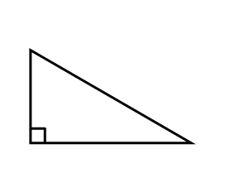

**Anatomy of a Right Triangle**

**Pythagorean Theorem:**



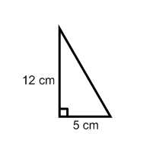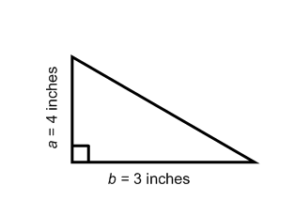**Use the Pythagorean Theorem to find the missing length:**

**Ex: Ex:**

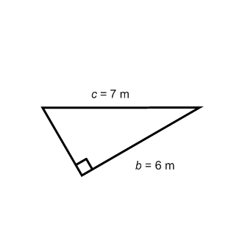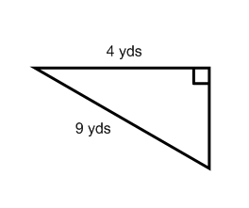**Ex: Ex:**

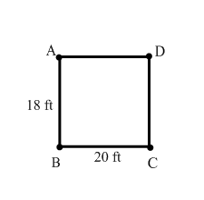**Ex:** Four people standing in a rectangle are playing Frisbee. Approximately how far is the throw from person A to person C?

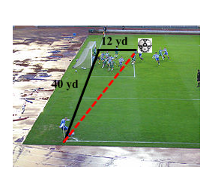**Ex:** A soccer player makes a corner kick to another player as shown below. How far is the kick, to the nearest yard?

**CONVERSE OF THE PYTHAGOREAN THEOREM:**

**Tell whether the following side lengths could form a right triangle. Show or explain your work.**

**Ex:** 8, 15, 17 **Ex:** 5, 9, 8 **Ex:** 13, 12, 5