**3.2: Solve Two-Step Equations**

**Goals:** *Solve two-step equations

**\***Solve equations by combining like terms first

*Set up two-step equations to model real-world situations

**\*\*TO SOLVE AN EQUATION WITH MORE THAN ONE STEP YOU:**

**Solve:**

**Ex: $\frac{x}{2}+5=11$**  **Ex:** 5*x* + 9 = 24

**Ex:** 4*y* – 4 = 16 **Ex: $-1=\frac{z}{3}-7$**

**Combining like terms:**

**\*Combine like terms first, then solve.**

**Ex:** 7*x* – 4*x* = 21 **Ex:** 4*w* + 2*w* = 24

**Ex:** 8*t* – 3*t* = 35 **Ex:** –16 = 5*d* – 9*d*

**Ex:** The output of a function is 3 less than 5 times the input. Find the input when the output is 17.

**Ex:** The output of a function is 5 more than –2 times the input. Find the input when the output is 11.

**Ex:** The output of a function is 4 less than 4 times the input. Find the input when the output is 3.

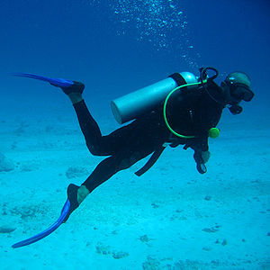**Ex:** As a scuba diver descends into deeper waters, the pressure of the water on the scuba diver’s body increases. The pressure at the surface of the water is 2117 pounds per square foot (*lb*/*ft*²). The pressure increases at a rate of 64 pounds per square foot each foot the diver descends. Find the depth at which a diver experiences a pressure of 8517 *lb*/*ft*².

**Ex:** Kim has a job where she makes $8/hr plus tips. Yesterday Kim made $53, $13 of which were in tips. How many hours did she work?