3.5-3.6 (Extension): Similar Figures
Goals: *Determine if two figures are similar by setting up a proportion
*Find the missing side of a figure based on similarity

Congruent figures: two figures that are both the same _________ and the same

____________

Similar Figures: two figures that are the same ________ but do not have to be the

same ___________. (They could be though)

~

Corresponding parts: two __________ of two similar figures that have the same relative position. They are in the “same spot”

**SIDES OF SIMILAR FIGURES ARE ________________**

*this means they form a ___________________

Decide if the given pairs of figures are similar or not.
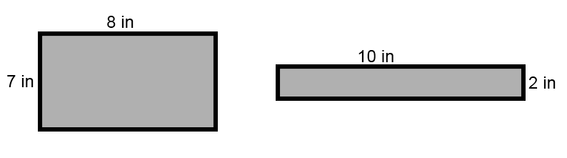
Ex:

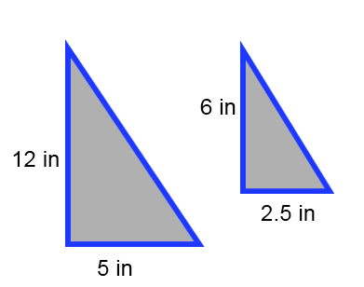

Ex:

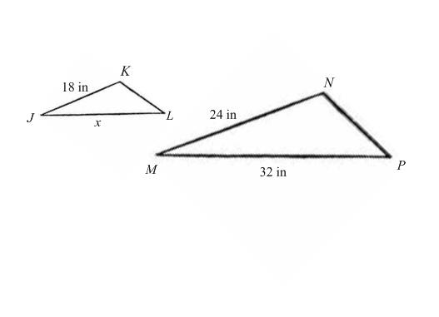
Ex: $Δ$JKL ~ $Δ$MNP. Find JL.

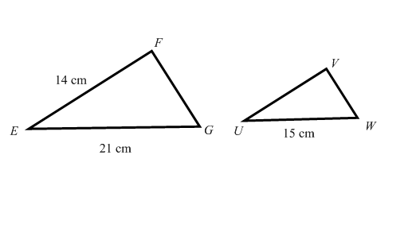
Ex: $Δ$EFG ~ $Δ$UVW. Find UV.

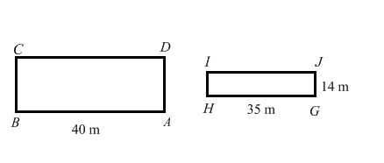
Ex: ABCD ~ GHIJ. Find AD.

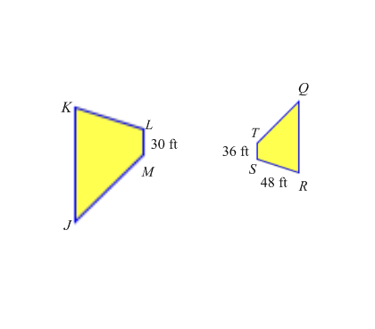
Ex: JKLM ~ QRST. Find KL.

Ex: Cape Hatteras Lighthouse in North Carolina casts a shadow 83.2 feet long. A man who is 5.8 feet tall casts a shadow of 2.5 feet. Draw a diagram and use your knowledge of similar figures to determine the height of the lighthouse.

