3.8: Rewrite Equations and Formulas
Goals: *Isolate a variable in a literal equation
*Rewrite an equation so it is in function form

Literal equation:

Ex: Solve ax + b = c for x This means to:

Solve the following equations for the given variable.

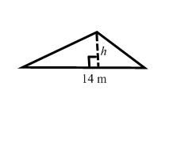
Ex: Solve A = ½bh for h Find h if the shown triangle has an area of 64.4 m²

Ex: p + qx = r for x

Ex: A = lw for l, then find l if A = 351 cm² and w = 13 cm

Ex: You are visiting Toronto over the weekend and look up a weather forecast. Find the low temperatures for Saturday and Sunday in degrees Fahrenheit. First rewrite the conversion formula so F is isolated:

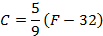
 | Friday | Saturday | Sunday
Forecast | Sunny | Sunny | Partly Cloudy
High | 21°C | 22°C | 16°C
Low | 13°C | 14°C | 10°C

**RECALL THAT ALL FUNCTIONS START WITH: **

So when you are rewriting an equation so it is in function form that means to isolate:

Ex: –2x + 3y = 6 Ex: 3x + 2y = 8

Ex: 4x – 2y = –6 Ex: –3x – y = 7

