4.2: Graph Linear Equations

Goals: *Use a table to graph a linear equation
*Graph horizontal and vertical lines
*Choose appropriate x values

Linear equation:

Solution:

Ex: Which ordered pair is a solution to: $3x−y=7$; (3, 4) or (1, –4)? Explain

Ex: Tell whether $\left(4,−\frac{1}{2}\right)$ is a solution to $x+2y=5$. Why or why not.

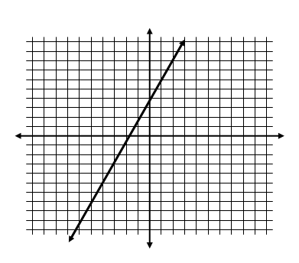

Ex: Are the following points solutions to the
linear equation represented by the line graphed?

- (1, 6)
- (–3, 2)

Graph a linear equation by making a table:

**MAKE SURE EQUATION IS IN _____________ FORM!

1. Rewrite the equation so it is in function form, which
means to isolate _____ Ex: $−2x+y=−3$

2. Choose 5 appropriate values for x. Typically these values are:

*You should not choose these five values in two cases:

1.

2.
3. Plug your 5 values into the function for x, find out what y is for each to complete your table.

4. Graph the ordered pairs you now have from your table.

Ex: Graph $y=2−2x$ Ex: Graph y + 3x = 2

Ex: Graph y = – 3x + 1 with a domain of x > 0 *which values can you not choose
for x? Why?

*Identify the range…

Ex: Graph $y=−\frac{1}{2}x+4$ **which values should you pick for x? Why?

Ex: Graph $y=\frac{2}{3}x−1$ with a domain of x < 0 then identify the range.

Ex: Graph y = –3 Ex: Graph x = 4

Ex: The distance, d, in miles, that a runner travels is given by the function d = 6t where t is the time (in hours) spent running. The runner plans to go for a 1.5 hour run. Set up a table and identify the domain and range of the function. Choose at least 4 values for t.

Ex: Suppose the same runner decides he wants to run 12 miles. Set up a new table with at least 3 values and identify the new domain and range.

Ex: For gas that costs $2 per gallon, the equation C = 2g gives the cost, C, in dollars for g gallons of gas. You plan to pump $10 worth of gas. Set up a table and identify the domain and range.

