4.3: Graph Linear Equations Using x and y Intercepts

Goals: *Identify x and y intercepts on a graph
*Find x and y intercepts from a linear equation
*Graph lines using x and y intercepts
*Interpret the meaning of x and y intercepts

x – intercept:

y – intercept:

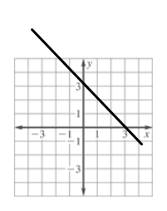
Identify the x and y intercepts of the lines graphed.
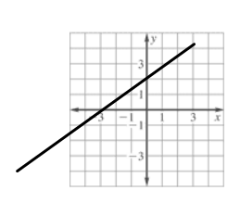
Ex: Ex:

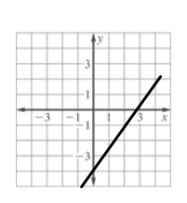
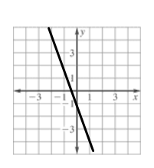
Ex: Ex:

Graph each line using the x and y intercepts.

Ex: 2x + 7y = 28 Ex: 3x + 2y = 6

Ex: 4x – 2y = 10 Ex: –3x + 5y = –15

Ex: x + 2y = 4 Ex: 3x – 4y = 12

Ex: y = x – 4 Ex: y = 2x + 6

Ex: You are helping plan an awards banquet for your school and you need to rent tables to seat 180 people. Tables come in two sizes. Small tables seat 4 people and large tables seat 6 people.
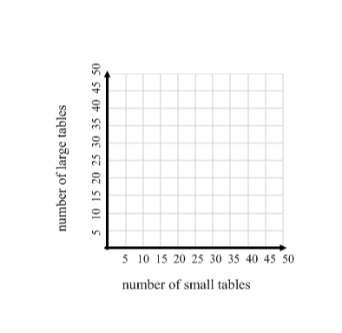
- Let x equal the number of small tables and y equal the number of large tables. Write an equation to represent the situation.

- Graph the equation.

- What do the intercepts mean?

- Give 4 possible combinations
of small and large tables you could
use.

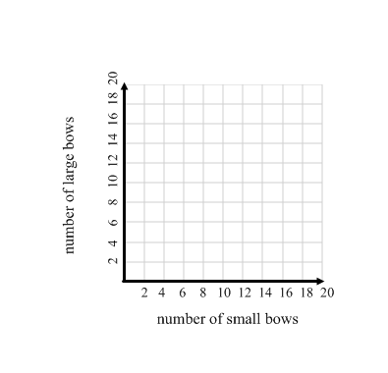
Ex: You make and sell decorative bows. You sell small bows for $3 and large bows for $5. You want to earn $60. Write an equation to represent the situation. Graph your equation. Give two possible combinations of small and large bows you could sell.

Ex: A submersible is designed to explore the ocean floor at –13,000 feet. The submersible ascends to the surface at a rate of 60 feet/minute. The equation:

e = 650t – 13000
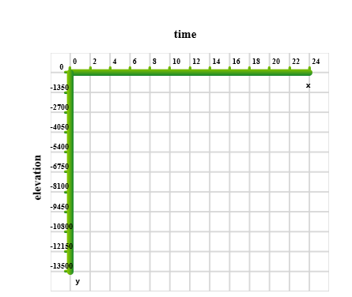
models this situation, where e is elevation and t is time (in minutes) since it began to ascend.

- Graph the equation.

- Explain the meaning of the x and y intercepts.

- Identify the domain and range.

