4.4: Find Slope and Rate of Change
Goals: *Find slope of a line given two points
*Find slope of a graphed line
*Find and interpret rate of change
Definition | Formulas
SLOPE -  SYNONYM:
  Formula | When To Use
Direction | Zero vs. Undefined

Find the slope of the line that passes through the given points. (Be sure to write down the formula you are using)

Ex: (5, 2) and (4, –1) Ex: (–2, 3) and (4, 6)

Ex: $\left(\frac{9}{2},5\right)$ and $\left(\frac{1}{2},−3\right)$ Ex: (3, 4) and (–2, 4)

Ex: (–5, 1) and (–5, 3)

Find the slope of the line graphed.

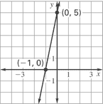
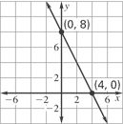
Ex: Ex:

Ex: Ex:
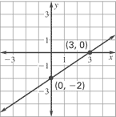
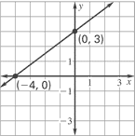

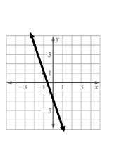
Ex: Ex:

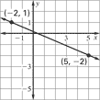

Rate of Change:

Ex: Gas prices went from $3 to $4 between June 1st of 2008 and August 1st of that same year. Find the rate of change for the price of gas during that time period?

Ex: Gas prices then began to fall after this spike. They fell back to $2 by November 19th. What is the rate of change of the price of gas for this time period?

Ex: Which time period had a greater rate of change? Why?

Ex: The table below shows the cost of using a computer at the internet café for a given amount of time. Find the rate of change with respect to time.

Time (hrs) | 2 | 4 | 6
Cost ($) | 7 | 14 | 21

