4.6: Model Direct Variation
Goals: *Identify a direct variation equation given an x/y relationship
*Graph a direct variation equation
*Write a direct variation equation given data

Direct Variation:

a =

Similar to: but: Since:

Graph will always:

1. Decide whether the equation represents direct variation. If so, identify the constant of variation.

Ex: 2x – 3y = 0 Can the equation be rewritten so it is in the form y = ax ?

Ex: −x + y = 4 Ex: −x + y = 1

Ex: 2x + y = 0 Ex: 4x – 5y = 0

2. Graph a direct variation equation. (Graph the same way as: )

Ex: Ex: y = −3x

Ex: y = 2x Ex: y = −½x

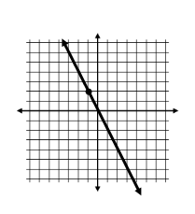
3. Write a direct variation equation.

Ex: 1.

2.

3.

4.
Find y when x = 60.
Ex: The graph of a direct variation equation passes through the point (4, 6).
- Write a direct variation equation relating x and y.

- Find y when x = 24.

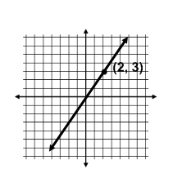
Ex: Write a direct variation equation and find y when x = 14.

Ex: The number s, of tablespoons of sea salt needed in a saltwater fish tank varies directly with the number w, of gallons of water in the tank. A pet shop owner recommends adding 100 tablespoons of sea salt to a 20 gallon tank.
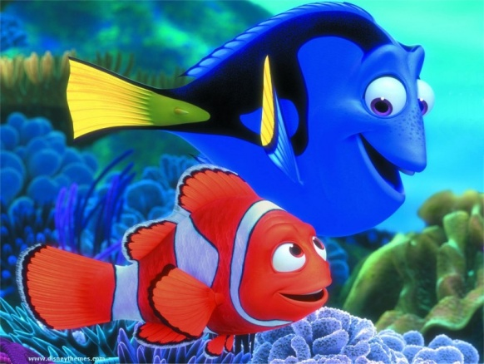
- Write a direct variation equation relating w and s.

- Find the number of tablespoons needed in a 30 gallon tank.

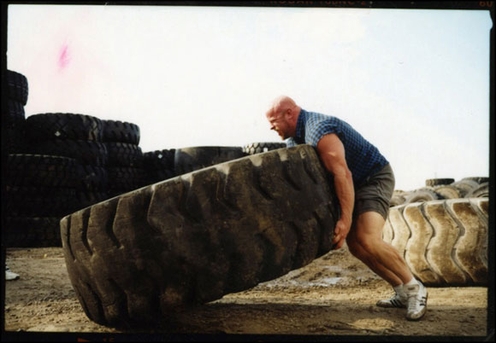
Ex: An object that weighs 100 pounds on Earth would weigh just 6 pounds on Pluto. Assume that weight p, on Pluto varies directly with weight e, on Earth.

- Write a direct variation equation relating e and p.

- What would a 750 pound rock weigh on Pluto?

Ex: The table shows the total cost c, of downloading s songs at an internet music site. Explain why c varies directly with s. Then write the direct variation equation.

s | c ($)
3 | 2.97
5 | 4.95
7 | 6.93

Ex: The table shows the total cost c, of buying d used DVD’s at a music store.

d | c ($)
3 | 25.77
6 | 51.54
9 | 77.31

- Explain why c varies directly with d.

- Write the direct variation equation.

