5.4: Writing Equations of Lines in Standard Form
Goals: *Write equivalent standard form equations
*Write equations in standard form
*Complete standard form equations
*Use standard form equations to solve combination problems

STANDARD FORM!

1. Write equivalent equations in standard form:
For each equation write two equivalent standard form equations:
Ex: 2x – 6y = 4 Ex: x – y = 3 Ex: x + 4y = 3

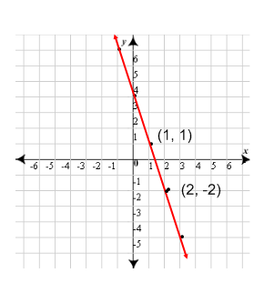
2. Write equations in standard form with given information.

Ex:

Ex: passes through (3, –1) (2, –3) Ex: passes through (2, 2) (4, –2)

3. Complete an equation in standard form
For each equation use the information to find the missing coefficient. Then write the equation in standard form.
Ex: Ax + 3y = 2, passes through the point (–1, 0)

Ex: –4x + By = 7, passes through the point (–1, 1)

Ex: Ax + 4y = 6, passes through the point (2, 0)

Ex: Ax + y = –3, passes through the point (2, 11)

Ex: Your class is taking a trip to the public library. You can travel in small and large vans. A small van holds 8 people and a large van holds 12 people. One possible way your class could get there is to fill 15 small vans and 2 large vans.
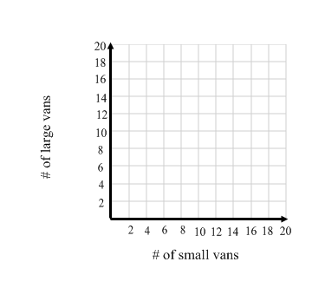
- Write an equation to model all of the possible combinations of small and large vans your class could take.

- Graph the equation.

- Use your graph to find more possible
combinations of vans.

Ex: At a flea-market t-shirts cost $4.50 and shorts cost $6. You have enough money that if you wanted to you could buy exactly 12 t-shirts and 9 pairs of shorts.
- Write an equation to model all of the possible combinations of t-shirts and shorts that you can buy.

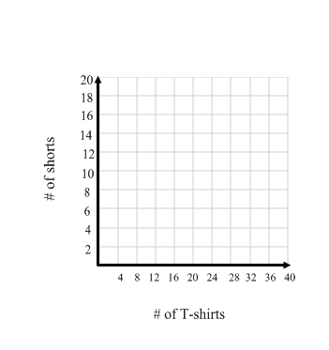
- Graph the equation.

- List the possible combinations of t-shirts and shorts you can buy.

