**5.6: Fit a Line to Data**

**Goals:** *Decide if a set of data has a positive correlation, negative correlation or relatively no correlation

*Write an equation of a line to model non-linear data if possible

**Positive correlation:**

**Negative correlation:**

**Relatively no correlation:**

**Ex:** State the type of correlation the graphs below display:

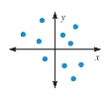

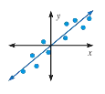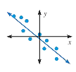

**Ex:** Describe a situation you would consider to represent a positive correlation

**Ex:** Describe a situation you would consider to represent a negative correlation

**Ex:** Describe a situation you would consider to have relatively no correlation

**Ex:** Describe the correlation of the data graphed in the scatter plot



**Ex:** Using the scatter plots above, predict a reasonable test score for 4.5 hours of studying and 4.5 hours of television watched.

**Make a scatter plot of the data then draw a line of best fit. Be sure to state which points you are using for your line, then write the equation of your line in slope-intercept form.**

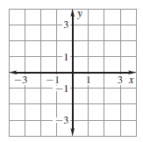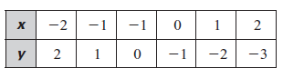**Ex:**



**Ex:** 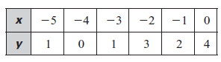

**Make a scatter plot of the data. *Describe* the correlation of the data. If possible, fit a line to the data and write the equation of the line.**

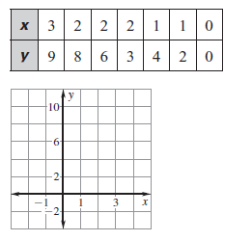**Ex: Ex:** 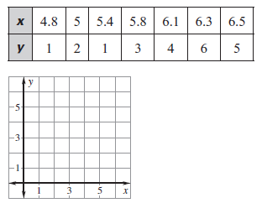

**Ex: Saturn’s Moons** The table shows a moon’s mean distance from the Saturn, the moon’s diameter, and the number of days it takes the moon to orbit Saturn.

