6.7: Graph Linear Inequalities in Two Variables
Goals: *Graph a linear inequality on a coordinate plane
- Decide if the line is solid or dotted
- Decide which half of the plane to shade
- Identify solutions to a linear inequality

Linear inequality:

Solution:

Ex: Which of the following are solutions to x – 3y < 6 ?

a. (0, 0) b. (6, –1) c. (10, 3) d. (–1, 2)

Ex: Tell whether the given ordered pair is a solution to: –x + 2y < 8

a. (0, 0) b. (0, 4) c. (3, 5) d. (–2, 3)

To Graph:

1.

*
*

2.

Graph the following linear inequalities:

Ex: y > 4x – 3 Ex: y > 3x + 1

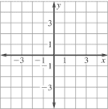

Ex: x + 2y < 0 Ex: x + 4y < –8

Ex: x – y > –1

Ex: You have 2 summer jobs at a youth center. You earn $8 per hour giving basketball lessons and $10 giving swimming lessons. Let x represent the number of hours you spend coaching basketball and y represent the amount of time you spent giving swimming lessons. Your goal is to earn at least $200 per week.

- Write an inequality to represent the situation

- Graph the inequality.

- Give two possible solutions so you would make the amount you want.
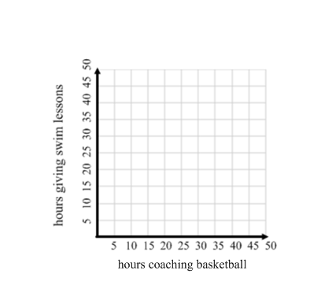

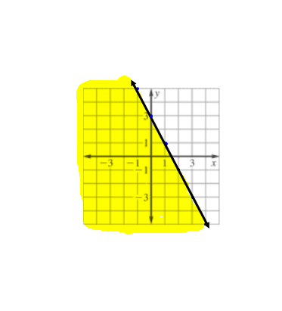
Write the inequality of the graph shown.
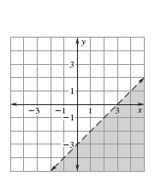
Ex: Ex:

