7.1: Solve Linear Systems by Graphing:

Goals: *Solve a system of equations by graphing
*Find a solution to system of equations

**RECALL**

A solution to a linear equation is:

Ex: 2x + 5y = 9, is (2, 1) a solution?

If you were to graph the line, would (2, 1) be a point on it? Why or why not?

System of Equations –

Solution to a system of equations –

Eventually we will know 3 ways to solve a linear system. The first is by graphing. It is the least convenient, but the best visually. This is a method you would use if giving an office presentation, for example.

**Since we already know that a solution to a single linear equation is also a point on the line, then we infer from this definition of a solution to a system of equations, that when graphed the solution must be a point on:

Decide if the given point is a solution to the system of equations:

Ex: x + y = –2 Ex: 2x – 3y = 4 Ex: 6x + 5y = –7
x + 5y = 2 2x + 8y = 11 x – 2y = 0
(–3, 1) (5, 2) (–2, 1)

Solve by graphing:

Ex: Graph the following lines in the same coordinate plane. Identify the solution to the system:

x + 2y = 7 and 3x – 2y = 5 *remember that in order to graph the lines you can use a table,
intercepts or slope – intercept. Choose the most appropriate method when graphing.

*Hint: Often times if you graph multiple (more than two points) you will be able to see the solution more easily.

What is the solution to the system? How do you know?

Solve each of the following systems by graphing. Be sure to state the solution.

Ex: –x + y = –7 Ex: –5x + y = 0
x + 4y = –8 5x + y = 10

Ex: –x + 2y= 3 Ex: x – y =5
2x + y = 4 3x + y = 3

Ex: 2x + 5y = 7 Ex: –x + y = 5
–x + 2y = –8 2x + y = 8

Ex: The parks and rec. department offers a seasons pass for $90. With a pass you pay $4 per session to use the tennis courts and without the pass you pay $13 per session.
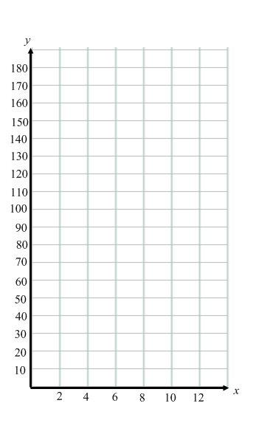
- Write a system of linear equations to describe the situation. (The total cost with and without a based on the number of times you use the tennis courts)

- Solve the system by graphing.

Ex: You sell earrings for $5 and necklaces for $10 and want to make $500. You also want to sell 60 items total. Write a system of equations to describe the total number of necklaces and earrings sold.

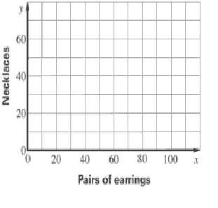

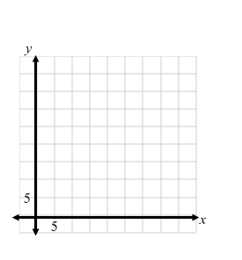
Ex: A business rents inline skates for $15 per day and bicycles for $30 per day. During one day the business does a total of 25 rentals and makes $450. Write and solve a system of equations by graphing to find the number of in-line skates and bicycles rented.

