7.6: Solve Systems of Linear Inequalities

Goals: *Solve a system of linear inequalities
*Find a solution to system of inequalities
*Write a system of linear inequalities

**RECALL**

How do you graph: x – y > 7 ?

Where are the solutions?

Now graph 2x + y < 6

Where are the solutions to the system?

Graph the following systems of inequalities:
Ex: y > – x – 2 Ex: y < x – 4
y < 3x + 6 y > – x + 3

Ex: y < 3x
y > –2x+ 1

Ex: y > –1 Ex: y > –x + 2
x > –2 y < 4
x + 2y < 4 x < 3

Ex: y > –x
y > x – 4
y < 5

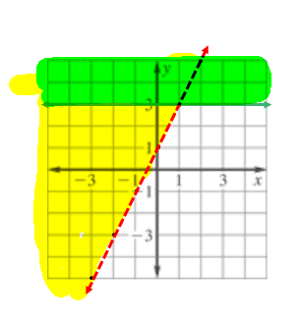
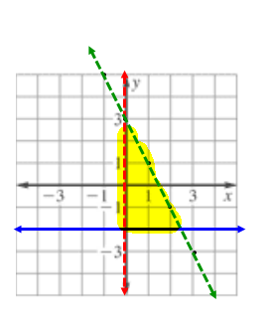
Write the linear system represented by the shaded region.

Ex: Ex:

Write and solve a system of linear inequalities

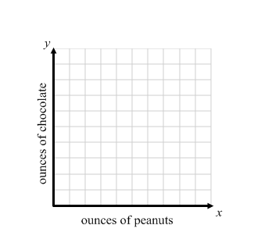
Ex: For a hiking trip, you are making a mix of x ounces of peanuts and y ounces of chocolate pieces. You want the mix to have less than 70 grams of fat and weigh less than 8 ounces. An ounce of peanuts has 14 grams of fat and an ounce of chocolate pieces has 7 grams of fat. Write and graph a system of inequalities that models the situation.

Ex: The NCAA regulates the lengths of aluminum bats used by college baseball teams. The NCAA states that the length (in inches) of the bat minus the weight (in ounces) of the bat cannot exceed 3. Bats can be purchased at lengths from 26-34 inches.

- Write and graph a system of linear inequalities that describes the information given above.

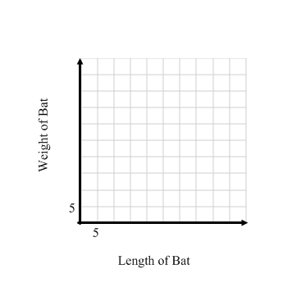
- A sporting goods store sells an aluminum bat that is 31 inches long and weighs 25 ounces. Use the graph to determine if this bat can be used by a player on an NCAA team.

