8.4: Use Scientific Notation
Goals: *Read and Write numbers in scientific notation
*Order numbers written in scientific notation
*Multiply and Divide numbers written in scientific notation

Standard Form:

Scientific Notation:

If the power of ten is positive, it tells you:

If the power of ten is negative, it tells you:

Write the following numbers in scientific notation:

Ex: 42,590,000 = _______________ X 10? Ex: 0.0000574 = ______________ X 10?

Ex: 539,000 = ____________________ Ex: 267,500,000 = __________________

Ex: 0.000486 = ____________________

Write the following numbers in standard form:

Ex: 2.0075 X 10⁶ = ________________ Ex: 1.685 X 10⁻⁴ =________________

Ex: 7.0235 X 10⁵ =________________ Ex: 3.096 X 10⁻⁷ = ________________

Ex: 4.5 X 10⁻⁴ = ___________________

Order numbers in scientific notation:

Ex: Order 103,400,000; 7.8 X 10⁸; 80,760,000 from least to greatest.

Ex: Order 93,000,000; 9.2 X 10⁶; 9,028,000 from least to greatest.

Multiply or divide numbers in scientific notation:

Ex: (8.5 X 10²)(1.7 X 10⁶) Ex: (1.5 X 10⁻³)²

Ex: (5.7 X 10³)(2.6 X 10⁴) Ex: (2.4 X 10⁻⁴)²

Ex: (1.3 X 10⁻⁵)² Ex: (1.1 X 10⁷)(4.2 X 10²)

Ex: 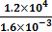 Ex: 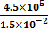

Ex: 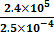

Ex: Blood flow is partially controlled by the cross-sectional area of the blood vessel through which the blood is traveling. Three types of blood vessels are venules, capillaries and arterioles.
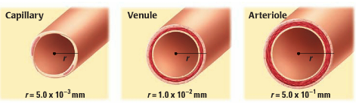

- Let r₁ be the radius of a venule, and let r₂ be the radius of a capillary. Find the ratio of r₁ to r₂. What does the ratio tell you?

- Let A₁ be the cross-sectional area of a venule and A₂ be the cross-sectional area of a capillary. Find the ration of A₁ to A₂. What does the ratio tell you?

