9.2: Multiplying Polynomials
Goals: * Multiply a monomial and a polynomial using distributive property
* Multiply Binomials by using the FOIL method
* Multiply polynomials

Multiply a monomial and a polynomial:

Ex: x(7x² + 4) Ex: $(2x^{3})(x^{3}+3x^{2}−x+5)$

Ex: $3x^{2}(2x−x^{2}+4x+3)$

Multiply binomials:

Ex: (x – 3)(3x + 2) Ex: (a + 3)(2a + 1)

Ex: (4n – 1)(n + 5) Ex: (x + 4)(2x – 1)

Multiplying Polynomials:

Ex: $(b^{2}+6b−7)(3b−4)$ Ex: $(2x^{2}+5x−1)(4x−3)$

Ex: $(x^{2}+2x+1)(x+2)$ Ex: $(3y^{2}−y+5)(2y−3)$

Ex: $(a^{2}+3a−4)(2a+3)$ Ex: $(2x^{2}−x−2)(3x−1)$

Ex: The dimensions of a rectangle are x + 3 and x + 2. Write a simplified expression to represent the area of the rectangle.

Ex: You are designing a rectangular skateboard park on a lot that is on the corner of a city block. The park will have a walkway along two sides that is x feet wide.
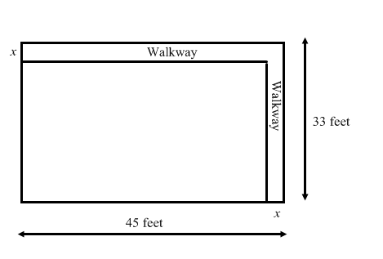
· Write a polynomial that represents the area of the skate park.

· What is the area if walkway is 3 feet wide?

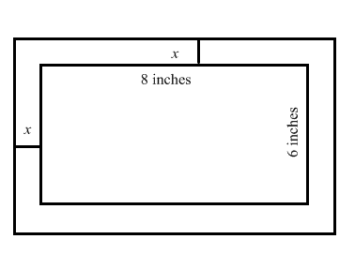
Ex: A rectangular trivet has a ceramic center and wooden border.
· Write a polynomial that represents the total area.

· What is the area if the width of the border is 2 inches?

