9.5: Factor x² + bx + c:
Goals: * Factor trinomials whose leading coefficient is 1
* Solve equations by factoring

Quadratic Function:

Factoring using the GCF is essentially:

Factoring trinomials into the product of two binomials is essentially:

**a needs to be 1**

Ex: Factor: x² + bx + c = ( )( )

x² + 11x + 18 *

Factor each trinomial:

Ex: x² + 3x + 2 Ex: a² + 7a + 10

Ex: t² + 9t + 14 Ex: x² + 8x + 12

Ex: t² + t – 20 Ex: n² – 6n + 8

Ex: x² – 4x + 3 Ex: n² – 5n + 6

Ex: y² + 2y – 15 Ex: w² + 6w – 16

Ex: y² + 3y – 10

Solve:

Ex: x² + 3x – 18 = 0 Ex: s² – 2s = 24

Ex: x² – 3x = 28

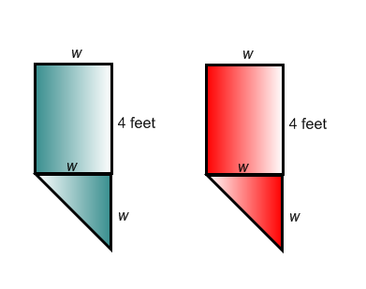
Ex: You are making banners to hang during school spirit week. Each banner requires 16.5 square feet of felt and will be cut as shown. Find the width of each banner.

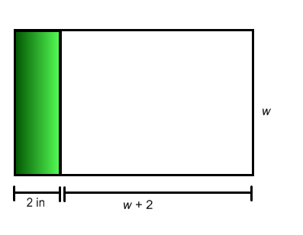
Ex: You are designing a team flag. The shaded region will have the team name. The entire flag requires 117 square inches of fabric. Find the width.

Factor completely.

Ex: –x² – 6x – 5 Ex: –x² – 4x – 3

Ex: –x² – 3x + 70 Ex: –x² + 17x – 72

Ex: 2a² + 12a + 16 Ex: 3x² + 24x – 144

Ex: 4x² – 40x + 84 Ex: –2x² – 10x – 12

