9.8: Factor Polynomials Completely
Goals: *Factor a common binomial
*Factor polynomials by grouping
*Factor polynomials completely

Factor a common binomial:

Ex: 2x(x + 4) – 3(x + 4) Ex: 4x(x – 3) + 5(x – 3)

Ex: 3y²(y – 2) + 5(2 – y) Ex: 2y²(y – 5) – 3(5 – y)

Ex: x(x – 2) + (x – 2)

Factor by grouping:

Ex: $x^{3}+3x^{2}+5x+\text{15}$ Ex: $y^{2}+y+\text{yx}+x$

Ex: $a^{3}+3a^{2}+a+3$ Ex: $x^{3}+2x^{2}+8x+\text{16}$

Ex: $r^{2}+4r+\text{rs}+4s$

Factoring by grouping (rearrange first):

Ex: $x^{3}−6+2x−3x^{2}$ Ex: $y^{2}+2x+\text{yx}+2y$

Ex: $x^{3}−\text{10}−5x+2x^{2}$

Factor completely:

Ex: $n^{2}+2n−1$ Ex: $4x^{3}−\text{44}x^{2}+\text{96}x$

Ex: $\text{50}h^{4}−2h^{2}$ Ex: $3x^{3}−\text{12}x$

Ex: $2y^{3}−\text{12}y^{2}+\text{18}y$ Ex: $m^{3}−2m^{2}−8m$

Ex: $x^{2}−4x−3$ Ex: $3x^{3}−\text{21}x^{2}−\text{54}x$

Ex: $x^{4}−x^{2}+3x^{2}−3$ Ex: $8d^{3}+\text{24}d$

Solve:

Ex: $3x^{3}+\text{18}x^{2}=−\text{24}x$ Ex: $w^{3}−8w^{2}+\text{16}w=0$

Ex: $c^{3}−7c^{2}+\text{12}c=0$ Ex: $2x^{3}−\text{18}x^{2}=−\text{36}x$

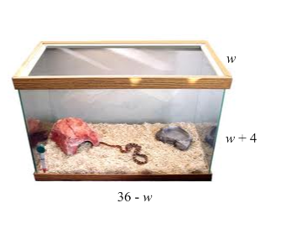
Terrarium A terrarium in the shape of a rectangular prism has a volume of 4608 cubic inches. Its length is more than 10 inches. The dimensions of the terrarium are shown. Find the length, width and the height of the terrarium.

