Name:__________________________________________________Date:_______________Per:______

Chapter 4 Practice Test

Read each problem carefully and be sure to show ALL of your work. Make sure all numbers are written clearly and to circle each answer. Do your best!

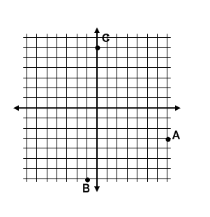
1. Write the ordered pairs that are represented by the points in the coordinate plane below. State that quadrant that each ordered pair is in.

A: ______

B: ______

C: ______

Graph the following equation by making a table.

2. 6y – 2x = 6

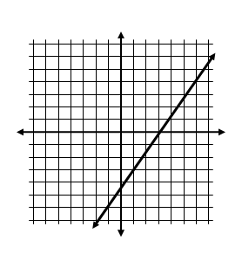
3. Is (0, 3) a solution to the equation of the line graphed? Explain why or why not.

4. You are going to a concert and can buy up to 6 tickets online. Tickets cost $40 each and there is a one-time processing fee of $15.

- Write a function to represent the total cost where x is the number of tickets

- What is the domain of the function? What is the range of the function?

Domain: __________________ Range: __________________

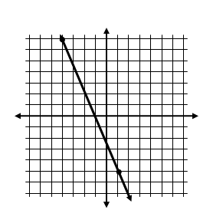
Find the slope of the line graphed.

5.

For numbers 6-7 find the slope of the line that passes through the given points.

6. 7. (20, 5) and (10, 1)

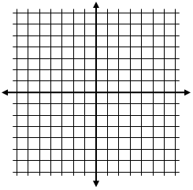

8. Graph 4y – 5x = −20 using x and y intercepts.

x – int: ___________

y – int: ___________

9. Find the x and y intercepts of the following equation:

3x + 2y = 7 x-int:_____________

y-int:_____________

10. Identify the slope and y-intercept of the equation y = 3x – 4
Slope:____________

y-intercept:________

11. Find the slope and y-intercept of the line with the equation: 5x – 2y = 10

Slope:____________

y-intercept:________

Identify the slope and y-intercept, then graph the equation using slope-intercept form.

12. y = 4 – 2x 13. 3x + 4y = 12

m = ___________ m = ___________

b = ____________ b = ____________

Decide whether the graphs of the two lines are parallel lines. Explain why or why not.

14. y = −3x – 2 ; 3y – 9x = −6

15. What is the value of the function when x = 4?

f(x) = −2x – 3

16. Let g(x) = 2x + 1. Find x when g(x) = 3

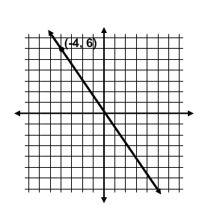
17. a) Assume x and y vary directly. Write the direct variation equation relating x and y.

b) Find y if x = −2

18. You are selling tickets to a school play and can sell to students and adults. Student tickets cost $5 each and adult tickets cost $10. You need to make $90.

a. Write an equation to represent the situation

b. Find the x and y intercepts of the graph of the equation.

x-int:_____________

y-int:_____________

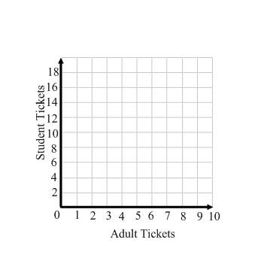
c. Graph the equation.

d. Give three possibilities for the number
of each type of ticket that could be sold.

