**Study Guide**

**4.4 – 4.5 Quiz**

**Slope and Graphing Using Slope – Intercept Form**

**4.4: Slope**

- Be able to find the slope of the line that passes through a pair of points. Also be able to identify when it is zero vs. undefined.

**Ex:** (–2, –1) and (4, 5) **Ex:** (3, –2) and (3, 6) **Ex:** (–10, –2) and (–8, 8)

**Ex:** (–9, 1) and (1, 1) **Ex:** (8, 2) and (4, 1) **Ex:** (12, 9) and (6, 6)

- Be able to find the slope of a graphed line. *Be able to identify when it is positive, negative, zero and undefined.

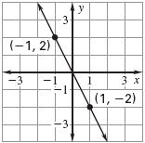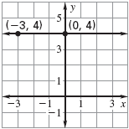**Ex: Ex:**

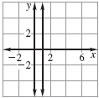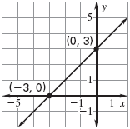**Ex: Ex:**

- Apply the slope formula to find a missing coordinate of an ordered pair:

**Ex:** (0, *y*) (2, 7) *m* = ½ **Ex:** (*x*, –2) (1, 7) *m* = 3

- Be able to apply slope to real-world problems to find rate of change:

**Ex:** The graph shows the cost (in dollars) to mail a letter that weighs one ounce during certain years.

* 1. Find the rates of change for each interval showing the change in cost per year of postage.
  2. Determine the time interval during which the cost to mail a one-ounce letter showed the greatest rate of change.
  3. Determine the time interval during which the cost to mail a one-ounce letter showed the least rate of change.

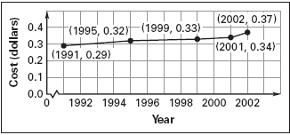**4.5: Graping Using Slope – Intercept Form**

**-** Be able to rewrite an equation so it is in slope – intercept form and identify the slope and *y* – intercept:

**Ex:** 3*x* – 3*y* = 12 **Ex:** *y* – 5*x* = –3 **Ex:** *x* + 4*y* = 6

- Be able to graph using slope – intercept form

**Ex:** *y* = 5*x* + 1 **Ex:** *y* = –2*x* – 3 **Ex: $y=-\frac{3}{4}x+1.5$**