**Study Guide**

**4.4 – 4.5 Quiz**

**Slope and Graphing Using Slope – Intercept Form**

**4.4: Slope**

- Be able to find the slope of the line that passes through a pair of points. Also be able to identify when it is zero vs. undefined.

**Ex:** (–2, –1) and (4, 5) **Ex:** (3, –2) and (3, 6) **Ex:** (–10, –2) and (–8, 8)

*m* = 1 *m* = Undefined *m* = 5

**Ex:** (–9, 1) and (1, 1) **Ex:** (8, 2) and (4, 1) **Ex:** (12, 9) and (6, 6)

*m* = 0 *m* =  *m* = –½

- Be able to find the slope of a graphed line. *Be able to identify when it is positive, negative, zero and undefined.

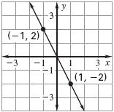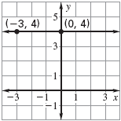**Ex: Ex:**

*m* = 0 *m* = –2

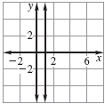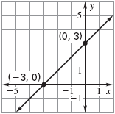**Ex: Ex:**

*m* = 1 *m* =

undefined

- Apply the slope formula to find a missing coordinate of an ordered pair:

**Ex:** (0, *y*) (2, 7) *m* = ½ **Ex:** (*x*, –2) (1, 7) *m* = 3

1. Start with 1. Start with

 

2. Plug in everything you can 2. Plug in everything you can

 

3. Simplify anything that you can 3. Simplify anything that you can

 

4. Solve like a proportion by cross multiplying 4. solve like a proportion by cross-

multiplying. (You need to make 3 into a

fraction)

1(2) = 2(7 – *y*) 

2 = 14 – 2*y* 9(1) = 3(1 – *x*)

–14 –14 9 = 3 – 3*x*

–12 =–2*y*  –3 –3

–2 –2 6 = –3*x*

6 = *y* –3 –3

–2 = *x*

- Be able to apply slope to real-world problems to find rate of change:

**Ex:** The graph shows the cost (in dollars) to mail a letter that weighs one ounce during certain years.

* 1. Find the rates of change for each interval showing the change in cost per year of postage.

From 1991-1995: $0.0075/year

From 1995-1999: $0.0025/year

From 1999-2001: $0.005/year

From 2001-2002; $0.03/year

* 1. Determine the time interval during which the cost to mail a one-ounce letter showed the greatest rate of change.

The greatest rate of change was between 2001-2002 because it increased by 3 cents per year.

* 1. Determine the time interval during which the cost to mail a one-ounce letter showed the least rate of change.

The least rate of change was between 1995-1999. It was only $0.0025/year.

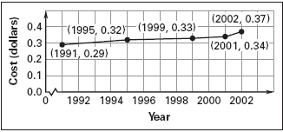

**4.5: Graping Using Slope – Intercept Form**

**-** Be able to rewrite an equation so it is in slope – intercept form and identify the slope and *y* – intercept:

**Ex:** 3*x* – 3*y* = 12 **Ex:** *y* – 5*x* = –3 **Ex:** *x* + 4*y* = 6

*y* = *x* – 4 *y* = 5*x* – 3 *y* = *x* + 1.5

*m* = 1, *b* = –4 *m* = 5, *b* = –3 *m* = , *b* = 1.5

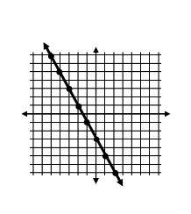- Be able to graph using slope – intercept form

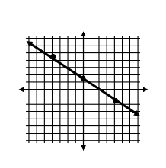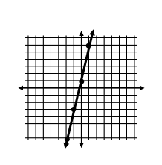**Ex:** *y* = 5*x* + 1 **Ex:** *y* = –2*x* – 3 **Ex: $y=-\frac{3}{4}x+1.5$**