**Chapter 5: Writing Linear Equations**

**Study Guide**

**5.1: Write equations of lines given slope and *y* – intercept or two points**

**Write the equation of the line with the given information:**

**Ex:** Slope: 0, *y* – intercept: ½ **Ex:** Passes through (0, 5) and (1, 7)

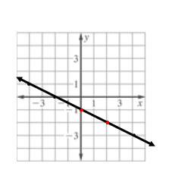

**Ex:** has the function values *f*(1) = –9, *f*(0) = –11 **Ex:**

**5.2: Write the equation of lines given slope and one point, or two points**

**Write the equation of the line with the given information:**

**Ex:** Slope 3, passes through (1, 1) **Ex:** Slope –5, passes through (–4, 7)

**Ex:** Passes through (1, 4) (2, 7) **Ex:** Passes through (–2, –2) (1, –1)

**Ex:** (–3, 1) (–3, –1) **Ex:** (1, 5) (–7, 5)

**Ex:** Passes through  **Ex:** *f*(3) = 1, *f*(6) = 4

**Ex:** You have a subscription to an online magazine that allows you to view 25 articles from the magazine’s archives. You are charged an additional fee for each article after the first 25 articles viewed. After viewing 28 articles, you paid a total of $34.80. After viewing 30 articles, you paid a total of $40.70.

1. What is the cost per archived article after the first 25 articles viewed?
2. What is the cost of the magazine subscription?

**Ex:** A delivery service charges a base price for an overnight delivery of a package, plus an extra charge for each pound the package weighs. A customer is billed $22.85 for shipping a 3-lb package and $40 for shipping a 10-lb package.

1. Write an equation that gives the total cost for shipping a package of any weight.
2. Then find the cost of shipping a 15-lb package.