**Chapter 5: Writing Linear Equations**

**Study Guide**

**5.1: Write equations of lines given slope and *y* – intercept or two points**

**Write the equation of the line with the given information:**

**Ex:** Slope: 0, *y* – intercept: ½ **Ex:** Passes through (0, 5) and (1, 7)

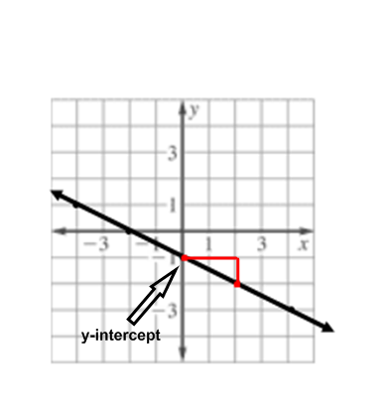

*y* = ½ *y* = 2*x* + 5

**Ex:** has the function values *f*(1) = –9, *f*(0) = –11 **Ex:**

Use ordered pairs (1, −9) and (0, −11)

Find the slope: $\frac{-11-(-9)}{0-1}=\frac{-2}{-1}=2$

*Recall that the *y*-intercept happens when *x* = 0

so *b* = −11

*y* = 2*x* – 11

*y* = –½ *x* – 1

**5.2: Write the equation of lines given slope and one point, or two points**

**Write the equation of the line with the given information:**

**Ex:** Slope 3, passes through (1, 1) **Ex:** Slope –5, passes through (–4, 7)

*y* = *mx* + *b* *y* = *mx* + *b*

1 = 3(1) + *b* 7 = −5(−4) + *b*

1 = 3 + *b* 7 = 20 + *b*

−2 = *b* −13 = *b*

*y* = 3*x* – 2 *y* = –5*x* – 13

**Ex:** Passes through (1, 4) (2, 7) **Ex:** Passes through (–2, –2) (1, –1)

$m=\frac{7-4}{2-1}=3$ $m=\frac{-1--2}{1--2}=\frac{1}{3}$

*y* = *mx* + *b y* = *mx* + *b*

4 = 3(1) + *b* −1 = $\frac{1}{3}\left(1\right)+b$

4 = 3 + *b* −1 = $\frac{1}{3}$ + *b*

1 = *b $-\frac{4}{3}=b$*

*y* = 3*x* + 1 *y* = 

**Ex:** (–3, 1) (–3, –1) **Ex:** (1, 5) (–7, 5)

*x* = –3 *y* = 5

**Ex:** Passes through  **Ex:** *f*(3) = 1, *f*(6) = 4

*y* =  *y* = *x* – 2

**Ex:** You have a subscription to an online magazine that allows you to view 25 articles from the magazine’s archives. You are charged an additional fee for each article after the first 25 articles viewed. After viewing 28 articles, you paid a total of $34.80. After viewing 30 articles, you paid a total of $40.70.

1. What is the cost per archived article after the first 25 articles viewed?

Create ordered pairs (3, 34.80) and (5, 40.70) *remember you only pay for the number of articles **after** the first 25.

The cost per article is $2.95. You get this by finding the slope and simplifying it.

1. What is the cost of the magazine subscription?

Using the slope and one of the ordered pairs and plugging into *y* = *mx* + *b* you are finding *b*, the *y*-intercept, which is the cost of the subscription when you are reading 0 extra articles.

*b* = $25.95

**Ex:** A delivery service charges a base price for an overnight delivery of a package, plus an extra charge for each pound the package weighs. A customer is billed $22.85 for shipping a 3-lb package and $40 for shipping a 10-lb package.

1. Write an equation that gives the total cost for shipping a package of any weight.

*y* = 2.45*x* + 15.50

1. Then find the cost of shipping a 15-lb package.

*y* = $52.25