Perimeter, Area and Circumference
Study Guide

Perimeter:

· How can you always find perimeter of a figure? Add up all the sides

· Which two shapes have a formula to find perimeter? What are the formulas? Rectangles and squares have perimeter formulas.

Rectangle: P = 2l + 2w Square: P = 4s

Find the perimeter of each figure. If you use a formula be sure to show which formula you use.
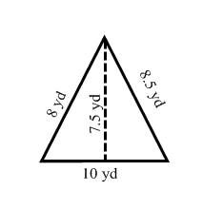
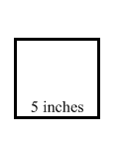
Ex: Ex: Ex:
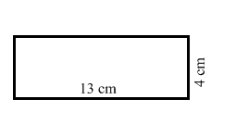

P = 2l + 2w P = 4s
P = 2(13) + 2(4) P = 4(5)
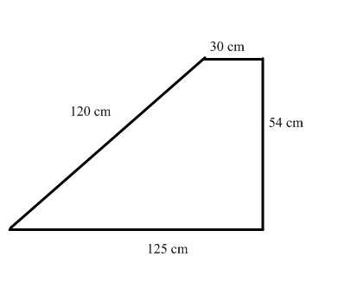
P = 26 + 8 P = 20 inches P = 8 + 8.5 + 10
P = 34 cm P = 26.5 yards

Ex: P = 120 + 30 + 54 + 125
P = 329 cm

· Be able to find missing lengths of figures
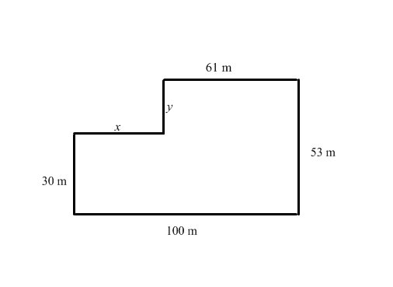
Find the missing length of each figure. Show or explain your work.
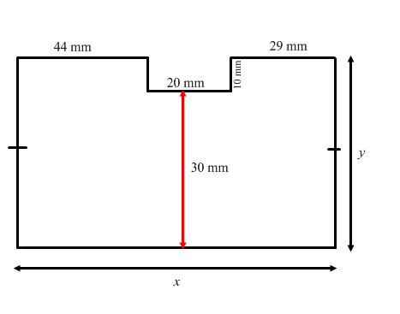
Ex: Ex:

x = 39 meters (Do 100 – 61) x = 93 mm (Add 44 + 20 + 29)

y = 23 m (53 – 30) y = 40 mm (30 + 10)

Circumference: Distance around a circle

· What are the two formulas that can be used to find the circumference of a circle?

C = and C =

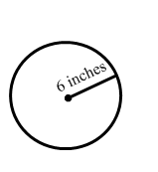
Find the circumference of the following circles.
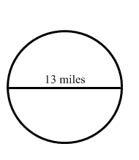
Ex: Ex:

Use C = since you know the diameter. Use C = since you know the radius.
C = 3.14(13) C = 2(3.14)(6)
C = 40.82 miles C = 37.68 inches

Area: Amount of space inside an object.

Write the formula needed to find the area of each figure on the line provided.

Rectangle: ___A = bh___________ Trapezoid: _____ A = ____________

Square: ___ A = s²_____________ Parallelogram: _____ A = bh_________

Triangle: ____ A = ___________ Circle: _____ A = _________________

Semi-circle: __________________

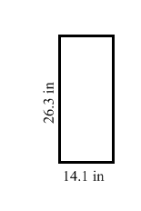
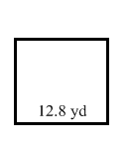
Find the area of each figure. Be sure to include the formula used and all work done.

Ex: Ex:

A = bh
A = (26.3)(14.1)
A = 370.83 in²

A = s²
A = (12.8)²
A = = 163.84 yd²

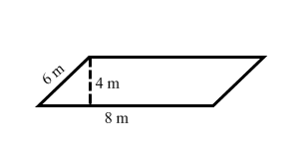

Ex: Ex:
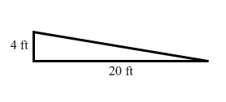

A = ½bh A = bh
A = ½(20)(4) A = 4(8)
A = 40 ft² A = 32 m²

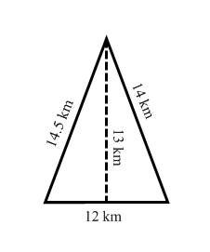
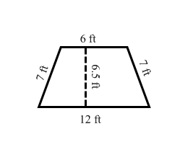
Ex: Ex:

A = ½ h(b₁ + b₂)
A = ½ (6.5)(12 + 6)
A = ½ (6.5)(18)

A = ½bh A = 58.5 ft²
A = ½ (13)(12)
A = 78 km²

Ex: Ex:

A = A =
A = (3.14)(6²) A = 3.14(6.5²)
A = 113.04 in² A = 132.665 mi²
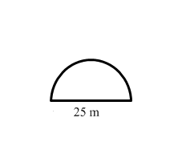

Ex:
A =
A = 245.3125 m²

· Be able to find area of complex figures or shaded regions.

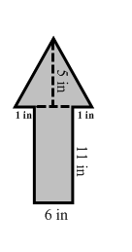
Find the area of the entire figure. Show your work.

Ex: Since the figure can be broken up into a triangle and a rectangle use both
formulas.

A = bh and A = ½ bh
A = 6(11) and A = ½ (8)(5) *The rectangle is 6 on the bottom, then add the two 1’s on each side of the triangle’s base.
A = 66 and A = 20
Total Area: 66 + 20
Total Area = 86 in²

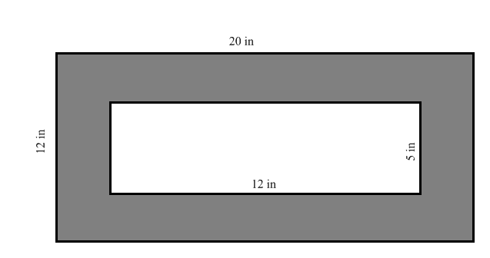

Ex:

To find the area of the shaded region find the area of the big rectangle, then the smaller rectangle and subtract.

Big Rectangle: Small rectangle:

A = bh A = bh
A = 12(20) A = 12(5)
A = 240 in² A = 60 in²

Shaded region = Area of Big – Area of small
Shaded region = 240 – 120
Shaded region = 120 in²

