Perimeter, Area and Circumference
Study Guide

Perimeter:

· How can you always find perimeter of a figure?

· Which two shapes have a formula to find perimeter? What are the formulas?

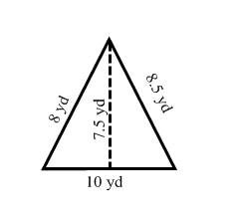
Find the perimeter of each figure. If you use a formula be sure to show which formula you use.

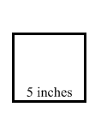
Ex: Ex: Ex:
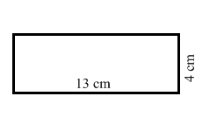

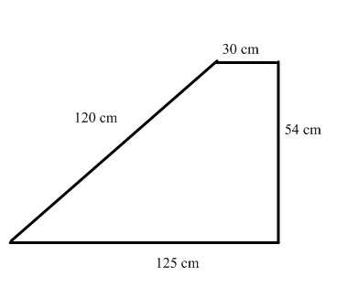

Ex:

· Be able to find missing lengths of figures
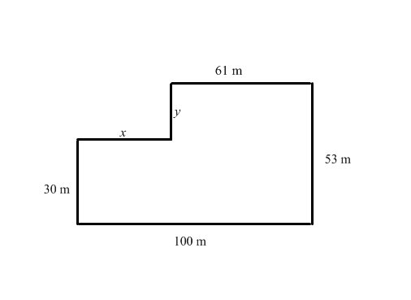
Find the missing length of each figure. Show or explain your work.
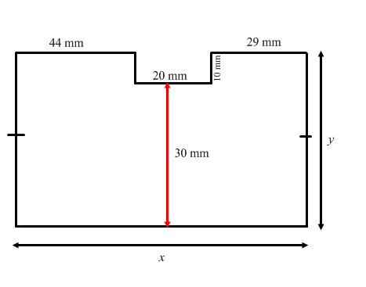
Ex: Ex:

x = x =

y = y =

Circumference:

· What are the two formulas that can be used to find the circumference of a circle?

Find the circumference of the following circles.
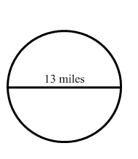
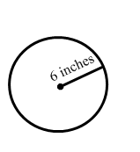
Ex: Ex:

Area:

Write the formula needed to find the area of each figure on the line provided.

Rectangle: ______________ Trapezoid: _________________

Square: ________________ Parallelogram: ______________

Triangle: _______________ Circle: ______________________

Semi-circle: __________________

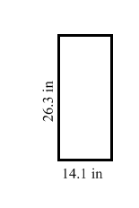
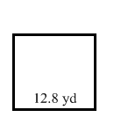
Find the area of each figure. Be sure to include the formula used and all work done.

Ex: Ex:

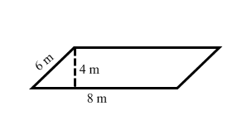
Ex: Ex:
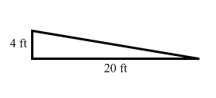

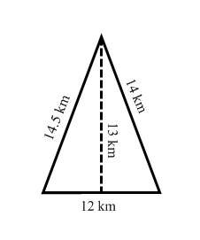
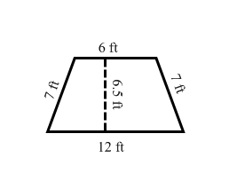
Ex: Ex:

Ex: Ex:

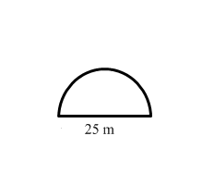

Ex:

· Be able to find area of complex figures or shaded regions.

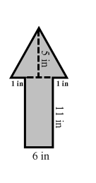
Find the area of the entire figure. Show your work.

Ex:

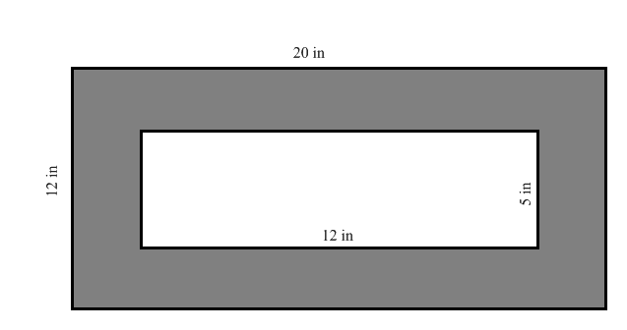
Ex:

