**Chapter 4: Solving Linear Equations**

**Study Guide**

**4.1: Plot Points in the Coordinate Plane**

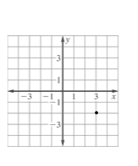**-** Identify/graph ordered pairs **Ex:** Write the coordinates of

- Identify the 4 quadrants point graphed and identify

the quadrant it lies in.

**4.2: Graph Linear Equations**

* Be able to graph an equation using a table (choose appropriate values for *x*)
* Be able to identify domain and range of a function

**Ex:** Graph 

|  |  |
| --- | --- |
| ***x*** | ***y*** |
|  |  |
|  |  |
|  |  |
|  |  |
|  |  |

**Ex:** You are transferring photos from your digital camera to a CD. Each photo on the camera takes up 2 megabytes of space. The number *p* photos that will fit onto a CD is given by the function *s* = 2*p* where *s* is the amount of space on the CD. One CD can store up to 700 megabytes of data. Identify the domain and range of the function.

Domain:____________________ Range:__________________

**4.3: Graph Linear Functions Using *x* and *y* intercepts**

* Find *x* and *y* intercepts from an equation
* Identify *x* and *y* intercepts from a graph
* Interpret the meaning of *x* and *y* intercepts as they apply to real-world problems

**Ex:** Find the *x* and *y* intercepts of the **Ex:** Graph using

equation  intercepts.

**Ex:** Your earn $16 an hour mowing lawns and $10 an hour washing windows. You want to make $500 in one week.

1. Write an equation to represent the situation
2. Graph the equation using *x* and *y* intercepts.
3. What do the intercepts mean in this situation?
4. What are three possible numbers of hours you can work at each job?
5. If you work 30 hours washing windows, how many hours do you have to work mowing lawns?



**4.4: Slope and Rate of Change**

* Find slope of a line that passes through two points
* Find slope of a line that is graphed
* Identify zero slope and undefined slope
* Find rate of change

**Ex:** Find the slope of the line that **Ex:** Find the slope of the line that

passes through the points (6, –4), (–5 , –8) passes through the points (–5, 5) (2, 5)

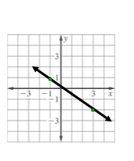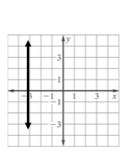**Ex:** Find the slope of the line **Ex:** Find the slope of the line

**Ex:** At 12:20 P.M. a parachutist is 6200 feet above the ground. At 12:27, the parachutist is 1100 feet above the ground. Find the average rate of change in feet per minute.

**4.5: Graphing Lines Using Slope-Intercept Form**

* Identify slope and y-intercept of a line by looking at the equation
* Write equations in slope intercept form
* Use equations in slope-intercept form to graph a line
* Identify parallel lines

**Ex:** Identify the slope and *y*-intercept **Ex:** Write the following equation in

 slope-intercept form then identify

slope and y intercept:



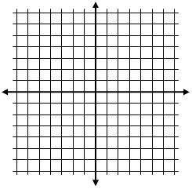**Ex:** Graph the following equation using slope-intercept form:



**Ex:** Tell whether the graphs of the two equations are parallel lines without graphing the lines:

 and 

**4.6: Direct Variation**

* Be able to decide if *x* and *y* vary directly
* Be able to write a direct variation given information and use to find missing values
* Be graph direct variation equations

**Ex:**  Decide if *x* and *y* vary direct. If so identify the constant of variation.

1. 6*y* – *x* = 0 b) *y* – 3*x* = −4

**Ex:** Given that *y* varies directly with *x*, write a direct variation equation. Then find *y* when *x* = 5

*x* = 3, *y* = 21

**Ex:** The amount of water, *w* (in gallons), used in a shower head varies directly with the number of minutes, *m*, the shower is run. After 5 minutes, 12.5 gallons of water have been used. Use the information provided to write a direct variation equation that relates *w* and *m*. Then find how long it would take for 25 gallons of water to be used.

**4.7: Linear Functions**

* Evaluate a function for a given value of *x*
* Find *x* for the given value of a function

**Ex:** Evaluate the function when *x* = −2 **Ex:** Find the value of *x* so *f*(*x*) = −1

*f*(*x*) =  *f*(*x*) = −2*x* + 5