**Lines, Triangles and Angles**

**Quiz Study Guide**

**Angles:**

**·You should be able to:**

* 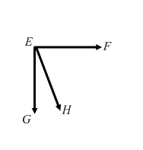 **Classify angles as acute, obtuse, right, adjacent, vertical, supplementary or complimentary and use all names that apply**

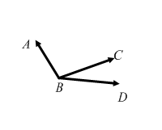

**Ex: Ex:**

ó*ABC* = ______________ ó*FEG* = ______________

ó*ABD* = ______________ ó*FEH* = ______________

ó*CBD* = _______________ ó*HEG* = _______________

ó*ABC* and ó*CBD* = _____________ ó*FEH* and ó*HEG* = _____________

_____________

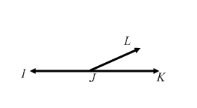

**Ex:** ó*IJL* = ______________

ó*IJK* = ______________

ó*LJK* = _______________

ó*LJI* and ó*KJL* = _____________ and ______________

* Identify the vertices of the previous three examples.

1. _____________
2. _____________
3. _____________

**·You should be able to use angle relationships to find missing angle measures.**

**Ex:** The measure of angle 1 is 30°. Angles 1 and 2 are complimentary. Find the measure of angle 2.

**Ex:** The measure of angle 1 is 125°. Angles 1 and 2 are supplementary. Find the measure of angle 2.

**Ex:** Angles 1 and 2 are vertical. The measure of angle 1 is 45°. Find the measure of angle 2.

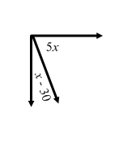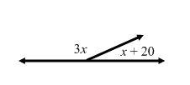**Use the given information to find the value of *x*.**

**Ex: Ex:**

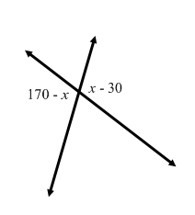

**Ex:**

**Angles formed by a Transversal:**

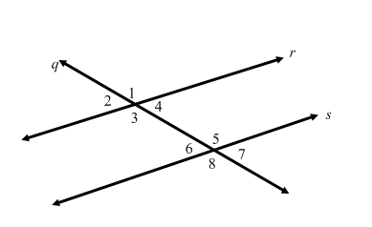**·You should be able to identify angle pairs formed by a transversal intersecting parallel lines and use their relationships to find missing angle measures.**

**Ex:** Which two lines are parallel? ______________ **Ex:** Which line is the transversal? ______________

**Ex:** Give one pair of corresponding angles: ____________ **Ex:** Give one pair of vertical angles: __________

**Ex:** Give one pair of alternate interior angles: __________ **Ex:** Give one pair of supplementary angles: _____

**Ex:** Give one pair of alternate exterior angles: __________

**Find the missing angle measures. Give the reason you know.**

**Ex:** Find *m*ó1 if *m*ó2 is 50º. **Ex:** Find *m*ó8 if *m*ó1 is 140°.

Measure: ___________Measure: ___________

Reason: ____________________Reason: ____________________

**Ex:** Find *m*ó6 if the *m*ó4 is 30°. **Ex:** Find *m*ó2 if *m*ó6 is 60°.

Measure: ___________Measure: ___________

Reason: ____________________Reason: ____________________

**Ex:** Find *m*ó3 if the *m*ó1 is 92°.

Measure: ___________

Reason: ____________________

**Triangles:**

**· You should be able to classify a triangle by its sides and angles.**

**· You should be able to find missing measures in triangles.**

**Ex:** A triangle with no equal sides is called: ______________

**Ex:** A triangle with all equal sides is called: ______________

**Ex:** A triangle with 2 equal sides is called: ________________

**Ex:**  A triangle with 1 ___________ angle is called: ________________

**Ex:** A triangle with 1 ____________ angle is called: ________________

**Ex:** A triangle with 3 _____________ angles is called: _______________

**Ex:** The number of sides equal in a triangle is also the number of ___________ that are equal. For example, if a triangle is isosceles, then it would be have _______ equal angles.

**Find the missing angle measure:**

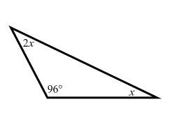

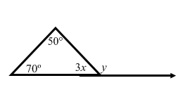**Ex: Ex:**