**Lines, Triangles and Angles**

**Quiz Study Guide**

**Angles:**

**·You should be able to:**

* 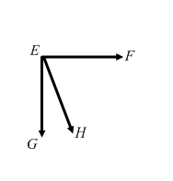 **Classify angles as acute, obtuse, right, adjacent, vertical, supplementary or complimentary and use all names that apply**

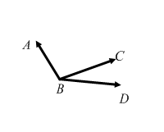

**Ex: Ex:**

∠*ABC* = __obtuse____________ ∠*FEG* = ____Right__________

∠*ABD* = __obtuse____________ ∠*FEH* = ____acute__________

∠*CBD* = _____acute__________ ∠*HEG* = ____acute___________

∠*ABC* and ∠*CBD* = __adjacent__________ ∠*FEH* and ∠*HEG* = __adjacent_________

____complimentary_______

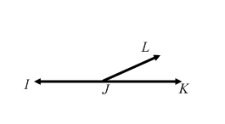

**Ex:** ∠*IJL* = _obtuse____________

∠*IJK* = ___straight___________

∠*LJK* = ___acute____________

∠*LJI* and ∠*KJL* = __adjacent___________ and ___supplementary___________

* Identify the vertices of the previous three examples.

1. ___B__________
2. ____E_________
3. ____J_________

**·You should be able to use angle relationships to find missing angle measures.**

**Ex:** The measure of angle 1 is 30°. Angles 1 and 2 are complimentary. Find the measure of angle 2.

60° (Because 90-30 is 60)

**Ex:** The measure of angle 1 is 125°. Angles 1 and 2 are supplementary. Find the measure of angle 2.

55° (because 180-125 is 55°)

**Ex:** Angles 1 and 2 are vertical. The measure of angle 1 is 45°. Find the measure of angle 2.

45° (Because vertical angles are the same size)

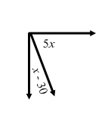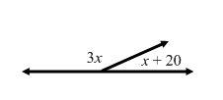**Use the given information to find the value of *x*.**

**Ex: Ex:**

**Since they form a straight line they are Since they form a right angle they are supplementary they add up to 180°. complimentary and add up to 90°.**

3*x* + *x* + 20 = 180 5*x* + *x* – 30 = 90

4*x* + 20 = 180 6*x* – 30 = 90

4*x* = 160 6*x* = 120

*x* = 40 *x* = 20

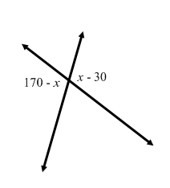

**Ex:** 170 – *x* = *x* – 30

+*x* +*x*

170 = 2*x* – 30

+30 +30

200 = 2*x*

100 = *x*

**Angles formed by a Transversal:**

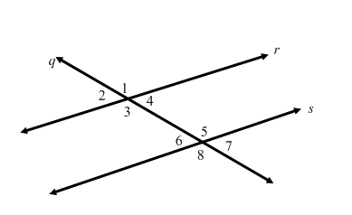**·You should be able to identify angle pairs formed by a transversal intersecting parallel lines and use their relationships to find missing angle measures.**

**Ex:** Which two lines are parallel? ____*r* and *s*______ **Ex:** Which line is the transversal? ___*q*______

**Ex:** Give one pair of corresponding angles: _1 & 5, or 4 & 7, 2 and 6 or 3 and 8_____

**Ex:** Give one pair of vertical angles: _1 and 3, 2 and 4, 5 and 8 or 6 and 7_________

**Ex:** Give one pair of alternate interior angles: __3 and 5 or 4 and 6________

**Ex:** Give one pair of supplementary angles: __1 and 4, 1 and 2, 2 and 3, 3 and 4, 5 and 6, 5 and 7, 6 and 8, or 8 and 7 ___

**Ex:** Give one pair of alternate exterior angles: ___2 and 7 or 1 and 8_______

**Find the missing angle measures. Give the reason you know.**

**Ex:** Find *m*∠1 if *m*∠2 is 50º. **Ex:** Find *m*∠8 if *m*∠1 is 140°.

Measure: ___130°________Measure: _140°__________

Reason: ____Supplementary________Reason: __Alternate Exterior____________

**Ex:** Find *m*∠6 if the *m*∠4 is 30°. **Ex:** Find *m*∠2 if *m*∠6 is 60°.

Measure: __30°_________Measure: __60°_________

Reason: ___Alternate Interior_______Reason: ____Corresponding_________

**Ex:** Find *m*∠3 if the *m*∠1 is 92°.

Measure: ____92°_______

Reason: _____Vertical Angles_______________

**Triangles:**

**· You should be able to classify a triangle by its sides and angles.**

**· You should be able to find missing measures in triangles.**

**Ex:** A triangle with no equal sides is called: ____scalene__________

**Ex:** A triangle with all equal sides is called: ____equilateral__________

**Ex:** A triangle with 2 equal sides is called: ______isosceles__________

**Ex:**  A triangle with 1 __obtuse_________ angle is called: ____an obtuse triangle____________

**Ex:** A triangle with 1 ___right_________ angle is called: _____a right triangle___________

**Ex:** A triangle with 3 ___acute__________ angles is called: ____an acute triangle___________

**Ex:** The number of sides equal in a triangle is also the number of ___angles________ that are equal. For example, if a triangle is isosceles, then it would be have _2______ equal angles.

**Find the missing angle measure:**

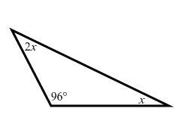

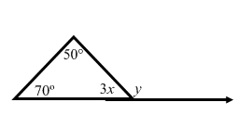**Ex: Ex:**

**Find *x* first:**

2*x* + 96 + *x* = 180 50 + 70 + 3*x* = 180

3*x* + 96 = 180 120 + 3*x* = 180

3*x* = 84 3*x* = 60

*x* = 28 *x =* 20

**Then find *y* (which is supplementary to the 3*x* angle which now equals 60.**

**So *y* = 120 since that is 180 – 60**