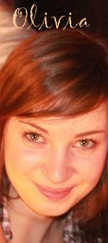
Hi! My name is Olivia. I am 16. My birthday is on the 25th march. I live in Saint Macaire en Mauges, it's a village close to Cholet. I've got a sister, her name is Cynthia and she is 14. My mother is Sandrine and my father is Laurent. They're divorced. I've got a dog, called Diablo. It's a Golden Retriever.. He is very cute. I love animals. I am not a big sporty. But I practise fitness once a week and i find it good! Sometimes, I have been running with friends. I don't play an instrument (it's not for me ;). I enjoy going out with my friend (go dancing, cinema, ...or just see them) I like cooking.. i'm greedy. :) I like swimming, go on the beatch and have sunbathing, enjoy watching series like Grey's Anatomy, 90210, Desperate Housewives... At school, I am learning English (for about 5 years), German (for about 3 years) and Italian (for this year). I love languages.. that's also why I'd like to become stewardess. :) I enjoy discovering other countries and try new experience! I have been twice in England and once in Germany (with school). It was really great. I am very exited to go to USA!!!! I have never been there! That’s would be very different from France but nice, I think we will have a great time. ♥

