Modern Motivational Theories
Theory | Description | Examples | Mnemonic
Hull’s Drive Reduction  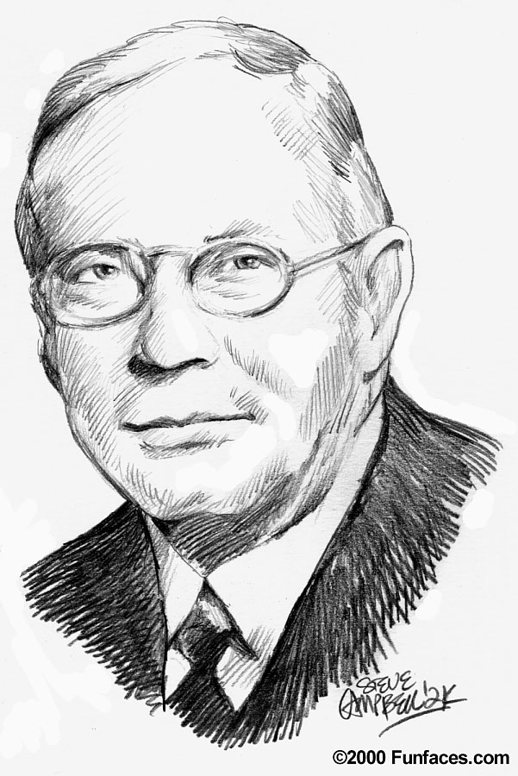 | Needs (biological requirement  & Drives (an impulse to act to satisfy drive)  Goal: Homeostasis  Drives:  Primary / Secondary  Cannot explain all our motivations | Drug Addicts  Physiological Need: DRUGS  Drive: cravings/withdrawal (reduce headaches, nausea, vomiting, convulsions from drug dependence)  Behavior: take drug  Oxygen or Air?
Arousal | Seek out optimum level of arousal  Yerkes-Dodson Law:  High A…  Easy Task WELL  Hard Task POOR | 1) Cliff Jumpers!  2) UFC Fighters  3)  1) Peyton (veteran) vs. Eli (not now, but as a rookie)  2)
Incentive | Drives are push,  Incentives are pulls of Behavior  Incentives can be stimuli we are drawn to due to learning | If food-satiated (full), incentive value of pizza might be enough to eat it
Maslow’s Hierarchy of Needs | 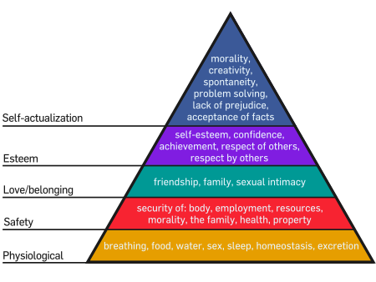 | Class Pyramid  (write an example from each)
Note: A 5th theory to know is “Instinct Theory” – see your book for this one

