Social Psychology
In-Class Notes
Take notes on the examples! They are vital to remembering the plethora of information and terms in this chapter. This is why I’ve given you most of the info, you just need examples.
ATTRIBUTION THEORY
When viewing others behavior, there are 2 ways to “attribute” a cause to it:
1)

2)

Kelley’s Covariation Model
Example: “Great Flick!”
- Consensus: how do other movie goers feel about this film?
- Distinctiveness: how does the same person react to other films?
- Consistency: how does that person feel about the film tomorrow morning when they first wake up

When do we make a Personal Attribution?
When do we make a Situational Attribution?

Person vs. Situation & Stability vs. Instability
Example: Madeline the Math Whiz…Assume you know nothing other than the following: Madeline gets a perfect score on the AP Calculus final exam. WHY?
- Person-stable attribution:

- Person-unstable attribution:

- Situation-stable attribution:

- Situation-unstable attribution:

Fundamental Attribution Error
ACTIVITY: QUIZ GAME!

We tend to _________estimate…

& _________estimate…

Examples:
- Position Paper on Castro
- Rude Woman
- Unusual Casting
- Marriage Satisfaction
- Political Consequences

What’s the actor-observer discrepancy and why does it happen?

Self-Fulfilling Prophecy
Defined: process by which one’s expectations about a person eventually lead that person to behave in ways that confirm those expectations
Examples:
- Israeli Defense Force
- Trial Judges
- Elementary IQ

Below, draw a circle of the 3 component parts of the self-fulfilling prophecy
using any of the examples you see in class.

Self-Serving Bias
Defined: tendency to overstate one’s role in a positive venture and underestimate it in a failure…remember the
Example:

Self-Effacing Bias (Modesty Bias)
Defined: involves blaming failure on internal, personal factors, while attributing success to external, situational factors

False Consensus Effect
Defined: tendency to overestimate the extent to which others share their our opinions, attributes, and behaviors
Example: Personality Test

Just World Belief
Defined: people bias themselves to believe that bad things happen to bad people & good things happen to good people.
What does this lead us to believe?
Examples:
- Rape –
How does the just world belief lead to blaming the victim?

- Unemployed – We assume that those who don’t have jobs or who just got fired are lazy, incompetent, or both. We fail to consider the infinite possible alternatives

ATTITUDES
What is an attitude?
- predisposition to evaluate some people, groups, or issues in a particular way
- can be - or +
Has 3 components
- _________ — thoughts about given topic or situation

- _________ — feelings or emotions about topic

- _________ — your actions regarding the topic or situation

The Effect of Attitude on Behavior
When do we behave in accordance with our attitudes?
  - Attitudes are extreme or are frequently expressed
  - Attitudes have been formed through direct experience.
  - You are very knowledgeable about the subject.
  - You have a vested interest in the subject.
  - You anticipate a favorable outcome or response from others for doing so.

When do Attitudes and Actions Line Up?
(Explain below using the anti-smoking example)
- Outside influences on what we do are minimal.

- We are keenly aware of our attitudes.

Cognitive Dissonance Theory (Festinger)
Defined: we act to reduce the dissonance (discomfort) we feel when our cognitions (thoughts) and actions are inconsistent
Examples:
- Peg-Board (or Dot) Game (insufficient-justification)
How does whether one can explain the behavior factor in?

- The Attractive Extremist

COMPLIANCE
Foot-in-the-Door
Defined: tendency for people who have first agreed to a small request to comply later with a larger request
Examples:
- Time Off from School

- Housewife Inventory

This only seems to work when…

The overall average increase in response rate when utilizing this strategy is _______% (not super huge, but it’s certainly better than not taking advantage of this phenomenon)

Door-in-the-Face
Defined: tendency for people to agree to a smaller request after first rejecting a larger, more burdensome request
Examples:
- Habitat for Humanity

- Girl Scout Cookies

Why does this occur? Possible explanations include:
  - Perceptual contrast –

  - Reciprocal concessions –

That’s Not All Folks
Defined: Influencer begins with a somewhat reasonable request, then decreases the request’s size/demand by offering a discount or bonus

Example: Cup Cake Salesman
Low-Balling
Influencer secures agreement with a request but then increases the size of that request by revealing hidden costs…Betting that you’ll go ahead with the purchase despite the added cost
Examples:
- Used Car Shop

- 6am Wake Up Call

Why does this occur?
- As ppl get increasingly committed to a course of action, they grow more resistant to changing their mind, even if the initial reasons for the action have been changed or withdrawn entirely.
- When people do not suspect that they are being duped, they feel a nagging sense of unfulfilled obligation to the person with whom they negotiated
  - Works best when second request is made by the same person

Role Playing – Zimbardo’s Prison Study
Design:

Results:

Surprised???? Could it happen to you?

Describe why this study is a good example of the “power of the situation”.

SOCIAL INFLUENCE: CONFORMITY
Defined: adjusting one’s behavior or thinking to coincide with a group standard
Examples:
- Heaven’s Gate
- Elevator Pressure
- Chameleon Effect

The Classics
Sherif’s Light Study
Design: Describe the “autokinetic” effect and how it was used in this study.

Results:

Asch’s Line Study (view movie)
Design: Be sure to draw the lines in addition to describing the design.

Results:

Why Do We Conform? (define, which studies make sense for each?)
Information Social Influence

Normative Social Influence

When Do We Conform?
Give examples of factors that make a judgment “important.”  Summarize Levels of Conformity  High Importance Easy =  Low Importance Easy =  Low Importance Hard =  High Importance Hard = | 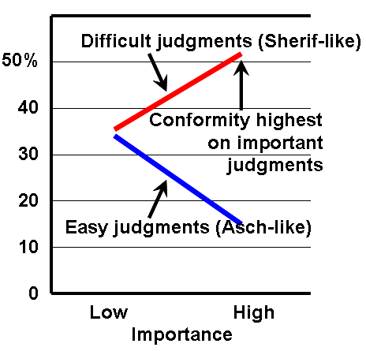

What conditions mark the optimal conditions for conformity?

What has happened to levels of conformity over since 1950s? WHY?

SOCIAL INFLUENCE: OBDIENCE
Defined: Behavior change produced by the commands of perceived authority

Stanley Milgram’s Obedience Study
Design:

Results: What conditions influence obedience?
  - Proximity
  - Contact
  - Perceived Authority
  - Replace Experimenter with Assistant
  - Other confederates present in room

SOCIAL INFLUENCE: THE PRESENCE OF OTHERS
Social Facilitation
Defined: improved performance of tasks in the presence of others
When does it occur?

Examples:
- Cockroaches

- Home Team Advantage

Why does Social Facilitation occur?
- mere presence
- others seen as social evaluators
- others present attentional conflict/distract from task

Social Loafing
Defined: tendency for people in a group to exert less effort when pooling their efforts toward attaining a common goal than when individually accountable = slacking off in groups
Example:

When is Social Loafing less likely to occur?

Deindividuation
Defined: loss of a person’s sense of individuality and the reduction of normal constraints against deviant behavior
Example: Trick or Treat

Group Polarization
Defined: the exaggeration, through group discussion, of initial tendencies in the thinking of group members
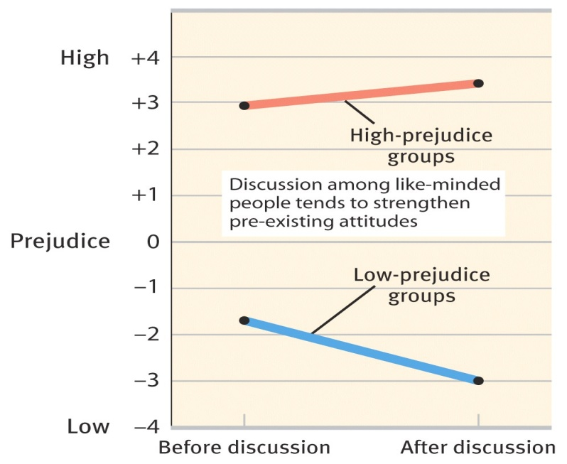 | Summarize the graph on the left:

Groupthink
Defined: mode of thinking that occurs when the desire for harmony in a decision-making group overrides realistic appraisal of alternatives
Alternate Def: group decision-making style that is characterized by an excessive tendency among group members to seek concurrence
Example: Bay of Pigs

How to Avoid?
1) avoid isolation; seek mediation
2) always use a devil’s advocate!
3) leaders should encourage critical discussion and not take a stand too early

SOCIAL RELATIONS
Prejudice
Defined: Undeserved, negative feelings toward persons based on their perceived membership in certain groups
Examples:
1. A Game of Shooting

2. Stereotype-Consistent Memories

What has happened to levels of expressed racism and sexism over the last 35 yrs?

Confirmation Bias
Defined: tendency to interpret, seek, and create information that seems to confirm original expectations

Self-Fulfilling Prophecy
Example: Academic Performance and teachers’ expectations feed each other.

Contact Theory
Defined: contact between hostile groups will reduce animosity, but only if the groups are made to work toward a superordinate goal

Examples:
1. Sherif’s Robbers-Cave Study –

2. Alien Takeover –

Aggression
Defined: any physical or verbal behavior intended to hurt or destroy
2 Types:
Instrumental –
Example:

Hostile –
Example:
What happens during the summer months?
Social Trap
Defined: a situation in which the conflicting parties, by each rationally pursuing their self-interest, become caught in mutually destructive behavior
Examples:

SOCIAL REALTIONS – ATTRACTIVENESS
Mere Exposure Effect
Defined: repeated exposure to novel stimuli increases liking of them
What are the limitations of the MEE?

Examples:
- Various Stimuli

- Fake College Students

Being Hot is Rewarding!
Examples:
- 5th grade teachers

- petitions

- Texas judges

- salaries

- Cinderella

What is a potential problem, however, of being beautiful?

Matching Hypothesis vs. Complementary Hypothesis
What characteristics do couples tend to share (match) more than 2 random people?

Do opposites attract (complement each other)?

Changing Opinions
Example: Do you like me now?
Mate Selection
Men Women

Examples:
- World Survey on What Makes a Good Mate
Both agreed on…

Men rated highest…

Women rated highest…

- Age Tendencies
Men want women who are ________________

Women want men who are ________________

- What Makes You Madder?

Men are Pigs
Examples:
- casual conversations

- reading stories

Pornography
Does watching violent porn contribute to violent behavior?

SOCIAL REALTIONS – CLOSE RELATIONSHIPS
Theories of Love
Passionate Love –

Companionate Love –

Sternberg’s Triangular Theory of Love (draw it) –

Equity Theory
Defined:

Social Exchange Theory
Defined:

Self-Disclosure
Defined:

SOCIAL RELATIONS – HELPING BEHAVIORS
Altruism
Defined:

What is the bystander effect?

Describe what happened to Kitty Genovese and why no one helped her.

Decision-Making Process for Bystander Intervention
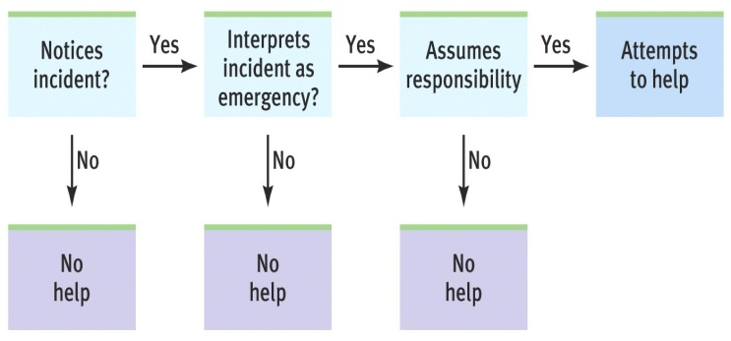
Why don’t people help?
Pluralistic Ignorance –the state in which ppl mistakenly believe that their own thoughts and feelings are different from those of others, even though everyone’s behavior is the same

Diffusion of Responsibility – the belief that others will or should take the responsibility for providing assistance to a person in need

Audience Inhibition – reluctance to help for fear of making a bad impression on the neutral observers

