Causes of the Great Depression
1 – Overspeculation – People borrow $$$ to buy stocks. Stocks go bad. Everyone frantically sells stocks hoping to salvage something from them.

2 – Federal Reserve’s failure to prevent bank failures; reduction in supply of money being circulated (people sat on their money, afraid to spend it)

3 – High tariffs (Hawley-Smoot Act of 1930) caused other countries to establish their own high tariffs = strangulation of world trade = world-wide depression
Impact
1 – Unemployment (25%!) and homelessness | 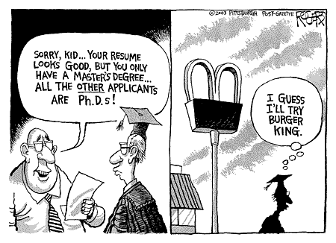
2 – Bank closings | 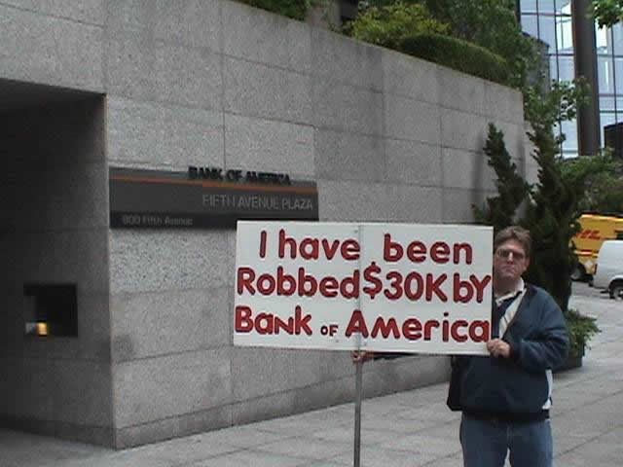
3 – Political unrest (labor unions getting very militant in their strikes) | 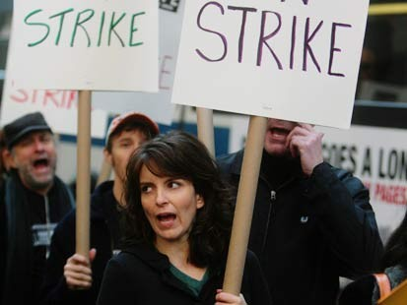
4 – Farm closings | 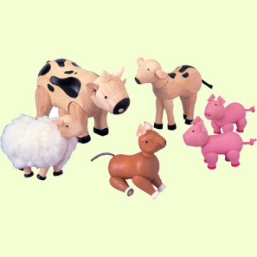

FDR’s NEW DEAL Saves the Day(?)
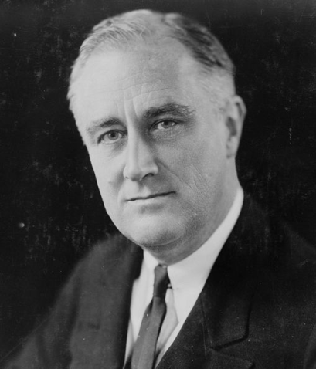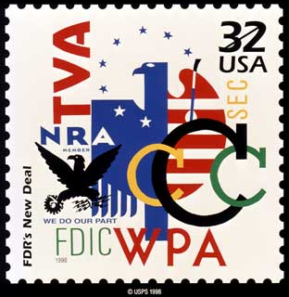
“WE HAVE NOTHING TO FEAR BUT FEAR ITSELF!” -- FDR
Big Idea: people push for and believe that government should play a larger role in people’s lives in order to avoid, prevent, and save people from the horrors that were seen during the Great Depression.

Program | Full Name | Description
WPA | Works Progress Administration | Relief: Immediate jobs created
AAA | Agricultural Adjustment Administration | Recovery: free money, free food  In this case, for farmers
FDIC | Federal Deposit Insurance Corporation | Reform: corrected unsound banking, investing practices; gave people confidence in the economic system
SSA | Social Security Act | Retirement program to take care of the elderly
TVA | Tennessee Valley Authority | Government take over of a common good – electricity in Tennessee

