Romulus, Remus, and the Founding of Rome

(Livy, Ab Urbe Condita I, 4—7)

People |  | Places and Things
Rea Silvia | daughter of Numitor, forced to become a Vestal Virgin | Alba Longa | very old town in Italy, founded by Aeneas’s son Ascanius
Mars | Roman god of war | Tiber | river in Latium (central Italy)
Numitor | king of Alba Longa, deposed by his brother Amulius | Ficus Ruminalis | The fig-tree near which the twins were found
Amulius | evil brother of Numitor; takes the power in Alba Longa by force | Lupercalia | ancient (and wild) festival for young men
Faustulus | shepherd who finds Romulus and Remus | Palatine | one of the seven hills of later Rome
Lycaean Pan | ‘Wolfman’ Pan, Greek shepherd god (half man, half goat) | Aventine | another of the seven hills of later Rome
 |  | Lavinium | very old town in Italy, founded by the Trojan Aeneas

[4.1] Sed debebatur, ut opinor, fatis tantae origo urbis maximique secundum deorum opes imperii principium. Vi compressa Vestalis cum geminum partum edidisset, seu ita rata seu quia deus auctor culpae honestior erat, Martem incertae stirpis patrem nuncupat. Sed nec di nec homines aut ipsam aut stirpem a crudelitate regia vindicant: sacerdos vincta in custodiam datur, pueros in profluentem aquam mitti iubet.

[4.2] Forte quadam divinitus super ripas Tiberis effusus lenibus stagnis nec adiri usquam ad iusti cursum poterat amnis et posse quamvis languida mergi aqua infantes spem ferentibus dabat. Ita velut defuncti regis imperio in proxima alluvie ubi nunc ficus Ruminalis est—Romularem vocatam ferunt—pueros exponunt. Vastae tum in his locis solitudines erant.

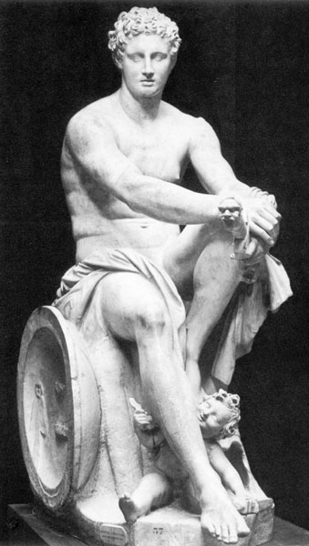

Marble statue of the Roman god Mars.

[4.3] Tenet fama cum fluitantem alveum, quo expositi erant pueri, tenuis in sicco aqua destituisset, lupam sitientem ex montibus qui circa sunt ad puerilem vagitum cursum flexisse; eam submissas infantibus adeo mitem praebuisse mammas ut lingua lambentem pueros magister regii pecoris invenerit— Faustulo fuisse nomen ferunt—ab eo ad stabula Larentiae uxori educandos datos.

[4.4] Sunt qui Larentiam volgato corpore lupam inter pastores vocatam putent; inde locum fabulae ac miraculo datum.

[4.5] Ita geniti itaque educati, cum primum adolevit aetas, nec in stabulis nec ad pecora segnes venando peragrare saltus. Hinc robore corporibus animisque sumpto iam non feras tantum subsistere sed in latrones praeda onustos impetus facere pastoribusque rapta dividere et cum his crescente in dies grege iuvenum seria ac iocos celebrare.
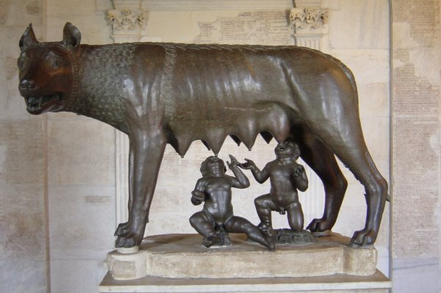

Statue of the-wolf suckling Romulus and Remus

[5.1] Iam tum in Palatio monte Lupercal hoc fuisse ludicrum ferunt, et a Pallanteo, urbe Arcadica, Pallantium, dein Palatium montem appellatum; ibi Evandrum, qui ex eo genere Arcadum multis ante tempestatibus tenuerit loca, sollemne allatum ex Arcadia instituisse ut nudi iuvenes Lycaeum Pana venerantes per lusum atque lasciuiam currerent, quem Romani deinde vocarunt Inuum.

[5.2] Huic deditis ludicro cum sollemne notum esset insidiatos ob iram praedae amissae latrones, cum Romulus vi se defendisset, Remum cepisse, captum regi Amulio tradidisse, ultro accusantes. Crimini maxime dabant in Numitoris agros ab iis impetum fieri; inde eos collecta iuvenum manu hostilem in modum praedas agere. Sic Numitori ad supplicium Remus deditur.

[5.3] Iam inde ab initio Faustulo spes fuerat regiam stirpem apud se educari; nam et expositos iussu regis infantes sciebat et tempus quo ipse eos sustulisset ad id ipsum congruere; sed rem immaturam nisi aut per occasionem aut per necessitatem aperiri noluerat.

[5.4] Necessitas prior venit: ita metu subactus Romulo rem aperit. Forte et Numitori cum in custodia Remum haberet audissetque geminos esse fratres, comparando et aetatem eorum et ipsam minime servilem indolem, tetigerat animum memoria nepotum; sciscitandoque eodem pervenit ut haud procul esset quin Remum agnosceret.
Ita undique regi dolus nectitur.

[5.5] Romulus non cum globo iuvenum—nec enim erat ad vim apertam par—sed aliis alio itinere iussis certo tempore ad regiam venire pastoribus ad regem impetum facit; et a domo Numitoris alia comparata manu adiuvat Remus. Ita regem obtruncat.

[6.1] Numitor inter primum tumultum, hostes invasisse urbem atque adortos regiam dictitans, cum pubem Albanam in arcem praesidio armisque obtinendam avocasset, postquam iuvenes perpetrata caede pergere ad se gratulantes vidit, extemplo advocato concilio scelera in se fratris originem nepotum, ut geniti, ut educati, ut cogniti essent, caedem deinceps tyranni seque eius auctorem ostendit.

[6.2] Iuvenes per mediam contionem agmine ingressi cum avum regem salutassent, secuta ex omni multitudine consentiens vox ratum nomen imperiumque regi efficit.

[6.3] Ita Numitori Albana re permissa Romulum Remumque cupido cepit in iis locis ubi expositi ubique educati erant urbis condendae. Et supererat multitudo Albanorum Latinorumque; ad id pastores quoque accesserant, qui omnes facile spem facerent parvam Albam, parvum Lavinium prae ea urbe quae conderetur fore.

[6.4] Intervenit deinde his cogitationibus avitum malum, regni cupido, atque inde foedum certamen coortum a satis miti principio. Quoniam gemini essent nec aetatis verecundia discrimen facere posset, ut di quorum tutelae ea loca essent auguriis legerent qui nomen novae urbi daret, qui conditam imperio regeret, Palatium Romulus, Remus Aventinum ad inaugurandum templa capiunt.

[7.1] Priori Remo augurium venisse fertur, sex voltures; iamque nuntiato augurio cum duplex numerus Romulo se ostendisset, utrumque regem sua multitudo consalutaverat: tempore illi praecepto, at hi numero avium regnum trahebant. Inde cum altercatione congressi certamine irarum ad caedem vertuntur; ibi in turba ictus Remus cecidit.

[7.2] Volgatior fama est ludibrio fratris Remum novos transiluisse muros; inde ab irato Romulo, cum verbis quoque increpitans adiecisset, "Sic deinde, quicumque alius transiliet moenia mea," interfectum. Ita solus potitus imperio Romulus; condita urbs conditoris nomine appellata.

[4.1] But the Fates had, I believe, already decreed the origin of this great city and the foundation of the mightiest empire under heaven. The Vestal was forcibly violated and gave birth to twins. She named Mars as their father, either because she really believed it, or because the fault might appear less heinous if a deity were the cause of it. But neither gods nor men sheltered her or her babes from the king's cruelty; the priestess was thrown into prison, the boys were ordered to be thrown into the river.

[4.2] By a heaven-sent chance it happened that the Tiber was then overflowing its banks, and stretches of standing water prevented any approach to the main channel. Those who were carrying the children expected that this stagnant water would be sufficient to drown them, so under the impression that they were carrying out the king's orders they exposed the boys at the nearest point of the overflow, where the Ficus Ruminalis (said to have been formerly called Romularis) now stands. The locality was then a wild solitude.

[4.3] The tradition goes on to say that after the floating cradle in which the boys had been exposed had been left by the retreating water on dry land, a thirsty she-wolf from the surrounding hills, attracted by the crying of the children, came to them, gave them her teats to suck and was so gentle towards them that the king's flock-master found her licking the boys with her tongue. According to the story his name was Faustulus. He took the children to his hut and gave them to his wife Larentia to bring up.

[4.4] Some writers think that Larentia, from her unchaste life, had got the nickname of `She-wolf' amongst the shepherds, and that this was the origin of the marvellous story.

[4.5] As soon as the boys, thus born and thus brought up, grew to be young men they did not neglect their pastoral duties but their special delight was roaming through the woods on hunting expeditions. As their strength and courage were thus developed, they used not only to lie in wait for fierce beasts of prey, but they even attacked brigands when loaded with plunder. They distributed what they took amongst the shepherds, with whom, surrounded by a continually increasing body of young men, they associated themselves in their serious undertakings and in their sports and pastimes.

[5.1] It is said that the festival of the Lupercalia, which is still observed, was even in those days celebrated on the Palatine hill. This hill was originally called Pallantium from a city of the same name in Arcadia; the name was afterwards changed to Palatium. Evander, an Arcadian, had held that territory many ages before, and had introduced an annual festival from Arcadia in which young men ran about naked for sport and wantonness, in honour of the Lycaean Pan, whom the Romans afterwards called Inuus.

[5.2] The existence of this festival was widely recognised, and it was while the two brothers were engaged in it that the brigands, enraged at losing their plunder, ambushed them. Romulus successfully defended himself, but Remus was taken prisoner and brought before Amulius, his captors impudently accusing him of their own crimes. The principal charge brought against them was that of invading Numitor's lands with a body of young men whom they had got together, and carrying off plunder as though in regular warfare. Remus accordingly was handed over to Numitor for punishment.

[5.3] Faustulus had from the beginning suspected that it was royal offspring that he was bringing up, for he was aware that the boys had been exposed at the king's command and the time at which he had taken them away exactly corresponded with that of their exposure. He had, however, refused to divulge the matter prematurely, until either a fitting opportunity occurred or necessity demanded its disclosure.

[5.4] The necessity came first. Alarmed for the safety of Remus he revealed the state of the case to Romulus. It so happened that Numitor also, who had Remus in his custody, on hearing that he and his brother were twins, and comparing their ages, and the character and bearing so unlike that of one in a servile condition, began to recall the memory of his grandchildren, and further inquiries brought him to the same conclusion as Faustulus; nothing was wanting to the recognition of Remus. So the king Amulius was being enmeshed on all sides by hostile purposes.

[5.5] Romulus shrunk from a direct attack with his body of shepherds, for he was no match for the king in open fight. They were instructed to approach the palace by different routes and meet there at a given time, whilst from Numitor's house Remus lent his assistance with a second band he had collected. The attack succeeded and the king was killed.

[6.1] At the beginning of the fray, Numitor gave out that an enemy had entered the City and was attacking the palace, in order to draw off the Alban soldiery to the citadel, to defend it. When he saw the young men coming to congratulate him after the assassination, he at once called a council of his people and explained his brother's infamous conduct towards him, the story of his grandsons, their parentage and bringing up, and how he recognised them. Then he proceeded to inform them of the tyrant's death and his responsibility for it.

[6.2] The young men marched in order through the midst of the assembly and saluted their grandfather as king; their action was approved by the whole population, who with one voice ratified the title and sovereignty of the king.

[6.3] After the government of Alba was thus transferred to Numitor, Romulus and Remus were seized with the desire of building a city in the locality where they had been exposed. There was the superfluous population of the Alban and Latin towns, to these were added the shepherds: it was natural to hope that with all these Alba would be small and Lavinium small in comparison with the city which was to be founded.

[6.4] These pleasant anticipations were disturbed by the ancestral curse--ambition--which led to a deplorable quarrel over what was at first a trivial matter. As they were twins and no claim to precedence could be based on seniority, they decided to consult the tutelary deities of the place by means of augury as to who was to give his name to the new city, and who was to rule it after it had been founded. Romulus accordingly selected the Palatine as his station for observation, Remus the Aventine.

[7.1] Remus is said to have been the first to receive an omen: six vultures appeared to him. The augury had just been announced to Romulus when double the number appeared to him. Each was saluted as king by his own party. The one side based their claim on the priority of the appearance, the other on the number of the birds. Then followed an angry altercation; heated passions led to bloodshed; in the tumult Remus was killed.

[7.2]The more common report is that Remus contemptuously jumped over the newly raised walls and was forthwith killed by the enraged Romulus, who exclaimed, `So shall it be henceforth with every one who leaps over my walls.' Romulus thus became sole ruler, and the city was called after him, its founder.

