Greek Myths I: Perseus and the Gorgon
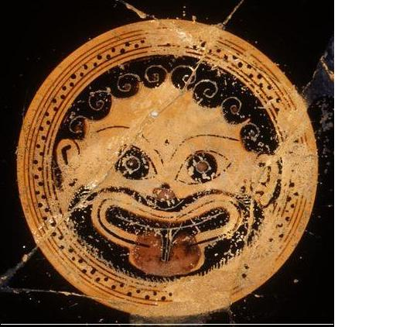
Head of Medusa

Characters | Places
Acrisius, king of Argos | Argos
Danae, daughter of Acrisius | Seriphos
Zeus
Perseus, son of Danae and Zeus
Medusa, one of the Gorgons
the Graeae
Polydectes, king of Seriphos

- What was the prophecy?

- How did Zeus enter the impenetrable bronze prison where Danae was kept?

- Why did Perseus set out to kill Medusa?

- How did he manage to kill her?

- How was the prophecy fulfilled?

- Describe the three Graeae.

