Greek Myths II: Daedalus and Icarus

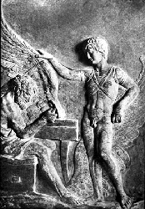
Daedalus and Icarus

Characters | Places
Daedalus | Athens
Icarus, son of Daedalus | Crete
Talaus, nephew of Daedalus | the Labyrinth
the Minotaur | Sicily
Minos, king of Crete | Icarian Sea

- What kind of a boy was Talaus? What kind of a boy was Icarus?

- What materials did Daedalus use for the wings?

- What advice did Daedalus give his son?

- What went wrong during Icarus’s flight?

- What other inventions did Daedalus make?

- How did Daedalus suffer for his mistakes and crimes?

Theseus and the Minotaur

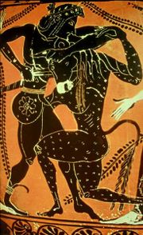
Theseus killing the Minotaur

Characters | Places
Theseus | Crete
Minos | the Labyrinth
Ariadne
Pasiphae
Aegeus
the Minotaur

Orpheus and Eurydice

Characters and Places

Orpheus | the Styx
Eurydice | the Underworld
Charon
Hades
Persephone
Cerberus

