Greek Myths III Theseus and the Minotaur
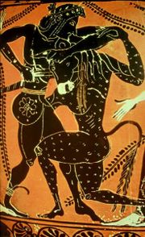
Theseus killing the Minotaur

Characters | Places
Theseus | Crete
Minos | Knossos
Ariadne | the Labyrinth
Pasiphae | Naxos
Aegeus
the Minotaur

- What is the origin of the Minotaur? What does he look like?

- Who had built the Labyrinth?

- How did Ariadne help Theseus? And why?

- Where did Theseus and Ariadne go after Theseus killed the Minotaur?

- What happened there?

