Greek Myths IV Orpheus and Eurydice

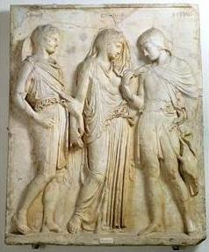
Orpheus, Eurydice and Hermes

Characters | Places
Orpheus, Thracian prince and singer | the Styx
Eurydice, wife of Orpheus | the Underworld
Charon, ferryman of the Underworld
Hades, god of the Underworld
Persephone, wife of Hades
Cerberus, three-headed guard-dog of the Underworld

- What is Orpheus’s special power?

- According to ancient Greek religious belief, what happened when a person died?

- Why did Orpheus go down into the Underworld?

- What gods, mythical persons and creatures did he meet there?

- Why was he given permission to take Eurydice back?

- What was the one condition to which Orpheus had to agree?

