The Sabine Women

(Livy, Ab Urbe Condita I, 9)

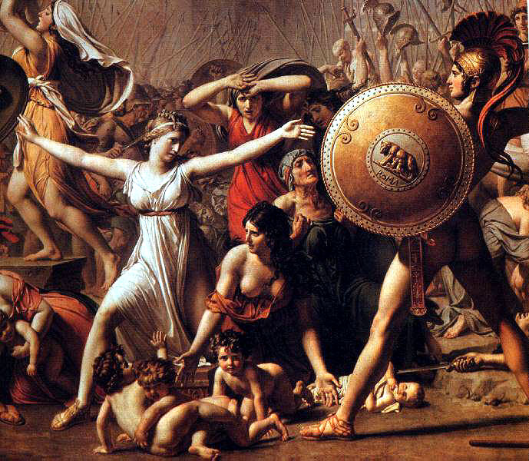

Rape of the Sabine Women. Painting by Jacques-Louis David.

People |  | Places and Things
Romulus | founder and first king of Rome | Senate | powerful Roman council
Neptune | Roman god of the seas | asylum | safe haven, refuge
Sabines | neighbors of the Romans | Consualia | games in honor of Neptune
 |  | ‘Thalassio!’ | ‘For Thalassius!’

[9.1] Iam res Romana adeo erat valida ut cuilibet finitimarum civitatum bello par esset; sed penuria mulierum hominis aetatem duratura magnitudo erat, quippe quibus nec domi spes prolis nec cum finitimis conubia essent.

[9.2] Tum ex consilio patrum Romulus legatos circa vicinas gentes misit qui societatem conubiumque novo populo peterent: urbes quoque, ut cetera, ex infimo nasci; dein, quas sua virtus ac di iuvent, magnas opes sibi magnumque nomen facere; satis scire, origini Romanae et deos adfuisse et non defuturam virtutem; proinde ne gravarentur homines cum hominibus sanguinem ac genus miscere.

[9.3] Nusquam benigne legatio audita est: adeo simul spernebant, simul tantam in medio crescentem molem sibi ac posteris suis metuebant. Ac plerisque rogitantibus dimissi ecquod feminis quoque asylum aperuissent; id enim demum compar conubium fore. Aegre id Romana pubes passa et haud dubie ad vim spectare res coepit.

[9.4] Cui tempus locumque aptum ut daret Romulus aegritudinem animi dissimulans ludos ex industria parat Neptuno equestri sollemnes; Consualia vocat. Indici deinde finitimis spectaculum iubet; quantoque apparatu tum sciebant aut poterant, concelebrant ut rem claram exspectatamque facerent.

[9.5] Multi mortales convenere, studio etiam videndae novae urbis, maxime proximi quique, Caeninenses, Crustumini, Antemnates; iam Sabinorum omnis multitudo cum liberis ac coniugibus venit. Invitati hospitaliter per domos cum situm moeniaque et frequentem tectis urbem vidissent, mirantur tam brevi rem Romanam crevisse.

[9.6] Vbi spectaculi tempus venit deditaeque eo mentes cum oculis erant, tum ex composito orta vis signoque dato iuventus Romana ad rapiendas virgines discurrit. Magna pars forte in quem quaeque inciderat raptae: quasdam forma excellentes, primoribus patrum destinatas, ex plebe homines quibus datum negotium erat domos deferebant.

[9.7] Vnam longe ante alias specie ac pulchritudine insignem a globo Thalassi cuiusdam raptam ferunt multisque sciscitantibus cuinam eam ferrent, identidem ne quis violaret Thalassio ferri clamitatum; inde nuptialem hanc vocem factam.

[9.8] Turbato per metum ludicro maesti parentes virginum profugiunt, incusantes violati hospitii foedus deumque invocantes cuius ad sollemne ludosque per fas ac fidem decepti venissent. Nec raptis aut spes de se melior aut indignatio est minor.

[9.9] Sed ipse Romulus circumibat docebatque patrum id superbia factum qui conubium finitimis negassent; illas tamen in matrimonio, in societate fortunarum omnium civitatisque et quo nihil carius humano generi sit liberum fore; mollirent modo iras et, quibus fors corpora dedisset, darent animos; saepe ex iniuria postmodum gratiam ortam; eoque melioribus usuras viris quod adnisurus pro se quisque sit ut, cum suam vicem functus officio sit, parentium etiam patriaeque expleat desiderium.

[9.10] Accedebant blanditiae virorum, factum purgantium cupiditate atque amore, quae maxime ad muliebre ingenium efficaces preces sunt.

[9.1] The Roman State had now become so strong that it was a match for any of its neighbours in war, but its greatness threatened to last for only one generation, since through the absence of women there was no hope of offspring, and there was no right of intermarriage with their neighbours.

[9.2] Acting on the advice of the senate, Romulus sent envoys amongst the surrounding nations to ask for alliance and the right of intermarriage on behalf of his new community. It was represented that cities, like everything else, sprung from the humblest beginnings, and those who were helped on by their own courage and the favour of heaven won for themselves great power and great renown. As to the origin of Rome, it was well known that whilst it had received divine assistance, courage and self-reliance were not wanting. There should, therefore, be no reluctance for men to mingle their blood with their fellow-men.

[9.3] Nowhere did the envoys meet with a favourable reception. Whilst their proposals were treated with contumely, there was at the same time a general feeling of alarm at the power so rapidly growing in their midst. Usually they were dismissed with the question, `whether they had opened an asylum for women, for nothing short of that would secure for them inter-marriage on equal terms.' The Roman youth could ill brook such insults, and matters began to look like an appeal to force.

[9.4] To secure a favourable place and time for such an attempt, Romulus, disguising his resentment, made elaborate preparations for the celebration of games in honour of `Equestrian Neptune,' which he called `the Consualia.' He ordered public notice of the spectacle to be given amongst the adjoining cities, and his people supported him in making the celebration as magnificent as their knowledge and resources allowed, so that expectations were raised to the highest pitch.

[9.5] There was a great gathering; people were eager to see the new City, all their nearest neighbours-the people of Caenina, Antemnae, and Crustumerium-were there, and the whole Sabine population came, with their wives and families. They were invited to accept hospitality at the different houses, and after examining the situation of the City, its walls and the large number of dwelling-houses it included, they were astonished at the rapidity with which the Roman State had grown.

[9.6] When the hour for the games had come, and their eyes and minds were alike riveted on the spectacle before them, the preconcerted signal was given and the Roman youth dashed in all directions to carry off the maidens who were present. The larger part were carried off indiscriminately, but some particularly beautiful girls who had been marked out for the leading patricians were carried to their houses by plebeians told off for the task.

[9.7] One, conspicuous amongst them all for grace and beauty, is reported to have been carried off by a group led by a certain Talassius, and to the many inquiries as to whom she was intended for, the invariable answer was given, `For Talassius.' Hence the use of this word in the marriage rites.

[9.8] Alarm and consternation broke up the games, and the parents of the maidens fled, distracted with grief, uttering bitter reproaches on the violators of the laws of hospitality and appealing to the god to whose solemn games they had come, only to be the victims of impious perfidy.
The abducted maidens were quite as despondent and indignant.

[9.9] Romulus, however, went round in person, and pointed out to them that it was all owing to the pride of their parents in denying right of intermarriage to their neighbours. They would live in honourable wedlock, and share all their property and civil rights, and--dearest of all to human nature-would be the mothers of freemen. He begged them to lay aside their feelings of resentment and give their affections to those whom fortune had made masters of their persons. An injury had often led to reconciliation and love; they would find their husbands all the more affectionate because each would do his utmost, so far as in him lay to make up for the loss of parents and country.

[9.10] These arguments were reinforced by the endearments of their husbands who excused their conduct by pleading the irresistible force of their passion--a plea effective beyond all others in appealing to a woman's nature.

