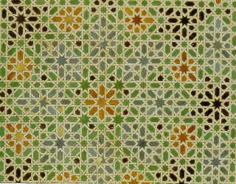
Islamic Contributions to the World

"The ink of the scholar is holier than the blood of the martyr."
- The Prophet Muhammad

Directions: You will complete a webquest in order to explore the contributions of Islamic achievement during "The Golden Age" of the Muslim Empire, including Muslim art, geometry, algebra, medicine and astronomy, and literature.

- Access the website by going directly to the following website http://trackstar.4teachers.org/trackstar/ts/viewTrack.do?number=380585 and clicking on “View in Frames.” In addition, you may access this directly through Mr. Guditus’ webpage on http://medfield.net.
- At the top of each of the 13 websites you are examine, you will notice a toolbar with the questions you are to answer on that website. These questions are also listed below. You should write your answers to these questions in the spaces below.
- Your answers should be in complete sentences. As a result, you may want to keep notes in the margin while reading, and then go back and write your answers.

Part I: Islamic Art and Geometry

- What specific features characterize Islamic art?

- What geometric figures are important to Islam?

- Where are they seen?

- What examples of symbolism does Islamic geometric art contain?

- Prioritize the five most important/impressive geometric patterns from the pictures of the Dome of the Rock (i.e. 1, 2, 3, 4, 5).

- What Muslim art is used in the Dome of the Rock?

Part II: Islamic Algebra

- Retell the accomplishments of Muslims in the field of Algebra and Trigonometry.

- List at least five categories of mathematical contributions that Muslims achieved.

Part III: Islamic Medicine

- List some of the important Muslim medical leaders and their accomplishments.

- How do medieval Muslim medical procedures compare to our medical procedures today (tell a few similarities)?

- How do Muslim medical procedures and hospitals influence our lives today?

Part IV: Islamic Astronomy

- List some pioneers of Muslim astronomy.

- What accomplishments were made by Muslim astronomers?

- What are three categories of Muslim astronomical accomplishments?

Part V: Islamic Literature

- Summarize the plot of Arabian Nights (aka The Thousand and One Nights) in one sentence.

- How has The Thousand and One Nights influenced our culture today?

Part VI: Islamic Contributions to the World

- Muhammad stated, "The ink of the scholar is holier than the blood of the martyr." Based on the sites you have visited, do you think Muslims have followed Muhammad's hope? Why or why not?

