Stars & Galaxies

Star Characteristics
Star
  - Body of gases that gives off energy in the form of light & heat
Stars vary in color & size
  - Surface temp. causes different colors
Stars composition
  - Mostly hydrogen
  - Helium, Carbon, oxygen, nitrogen, calcium

Motion of the Stars
Apparent motion
  - Motion that is visible to the unaided eye
  - Due to the rotation of earth on its axis
Most stars travel circumpolar to Polaris (the North Star)
  - Polaris is directly above the North Pole
As earth orbits the sun
  - different stars become visible during different seasons
  - Some stars are always visible b/c they are close to Polaris
Most stars have 3 motions
  - Rotation on an axis
  - Revolution around another star
  - Movement away or toward the earth
    - Remember: Red Shift and Blue Shift/Doppler Effect
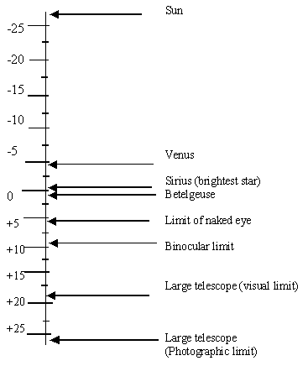
Distance to the Stars
- Measured in light years
  - Distance that light travels in one year
  - 9.5 trillion km/year
- Determining a star’s distance
  - Parallax
    - Measure the shift of a star in a 6 month period

Stellar Magnitudes
Apparent magnitude
  - Brightness of a star as it appears from earth
  - Assigned a number on the scale
    - Brightest stars = lowest numbers
    - Dimmest stars = highest numbers
    - 1st magnitude=brightest star in sky
    - 6th magnitude =faintest star seen from earth
    - A star brighter than a 1st magnitude star is given a negative number
Absolute Magnitude
- True brightness of a star
- How bright the star appears at 32.6 light years away
- Most absolute magnitude = -5 & +15
- Each star has an apparent & absolute magnitude

Classification of the Stars
H-R diagram
  - Plots surface temperature of stars against the absolute magnitude
  - As brightness of most stars increase, surface temperature increases
  - Most stars fall within a band called main-sequence stars
    - Most visible stars are main sequence stars
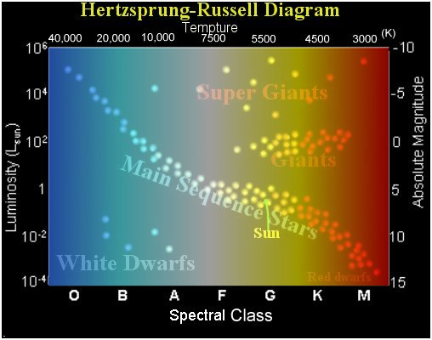

Stages of Stellar Evolution
Nebula
  - Baby star
  - A cloud of gas & dust
Protostar
  - Gravity causes nebula to shrink
  - Flattens into a spinning disk
Main Sequence stars
  - Nuclear fusion begins at 10,000,000° C
  - Longest stage
  - H atoms fuse into He atoms
  - Most stable stage
  - Sun is a main seq. star
Giants/Supergiants
  - Occurs when most Hydrogen is used
  - Core temp increases
  - He fuses into Carbon
  - Outer shell of star
  - expands (10x-100x plus)
White Dwarf
  - Begins when all Helium is fused into Carbon
    - No energy is released
    - Cooling ball of rock
  - Star loses its outer shell of gases
    - Core is visible
    - Core heats the expanding gases (planetary nebula
  - Stages of stellar evolution (cont.)
  - Some white dwarfs can explode into novas/supernovas
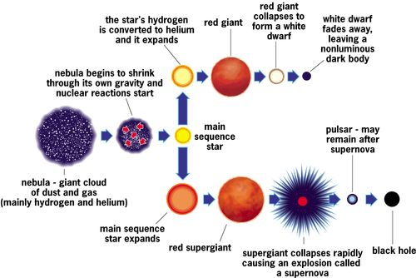

Star Groups
Constellations
  - Fixed patterns of stars in the sky
  - Astronomers recognize 88
  - Stars are labeled according to apparent magnitude
    - Brightest – alpha
    - 2nd brightest - beta
Galaxies
- A large group of stars held together by gravity
- Typical Galaxy
    - 100,000 light years diameter
    - 100 billion stars
- Our Galaxy – Milky Way
- Types of Galaxies
    - Spiral (where earth is located!)
    - Elliptical
    - Irregular

