Document A: The Mauryan Empire, 322-188 BCE (Modified)

Founding
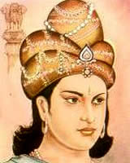
Along the Ganges River, the Mauryan Empire began to take shape under Chandragupta Maurya. In 305, Seleucus, another important leader, decided to reclaim parts of India. By the time he moved his army into the region, however, he faced the huge Mauryan army with its 700,000 soldiers, 10,000 chariots, and 9,000 war elephants. Seleucus wisely called it quits, signed a treaty with Chandragupta, gave him a daughter in marriage, and went home with a consolation prize of 500 war elephants. Chandragupta’s son then pushed the Maurya state southward into India, and his grandson, Ashoka (Asoka, 272-232 BCE) completed the conquests by taking control of much of the rest of India.

Administration
The Mauryans appear to have chosen to imitate and improve upon governmental methods developed earlier by the Persians, another major empire during this time. They divided the state into provinces, districts, and villages. Royal officials, spread out across the cities and countryside, keeping order and collecting taxes from villages. Well-maintained roads and swift postal riders enabled the emperor to control this vast area. An elaborate system of spies kept him informed. The government regulated everything from copper, lead, tin, bronze, and iron works to gum, dye, perfume, drug, and pottery industries.
Emperor Ashoka
www.teachindiaproject.org

Pataliputra, the capital, was at the center of busy he Mauryan economy and trade. Megathenes, the third-century Greek historian, describes city walls that were nine miles long and half a mile wide with 570 turrets. Inside the walls were palaces, temples, a library, parks, and gardens. Under Ashoka, Pataliputra became perhaps the world’s largest city, with between 200,000 and 300,000 people.

Religion
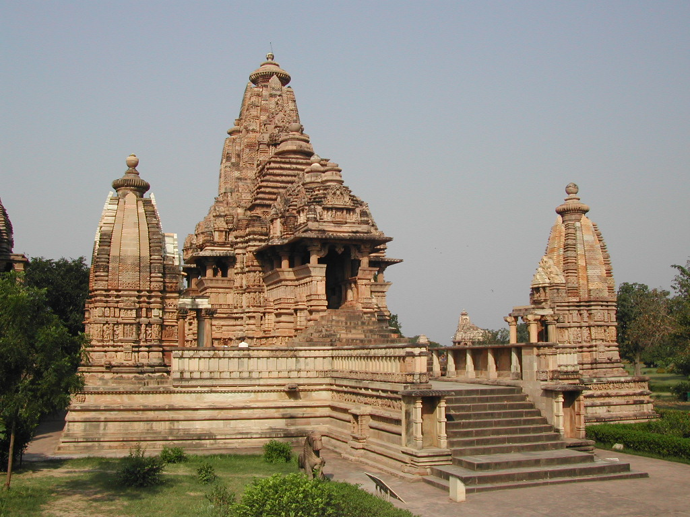
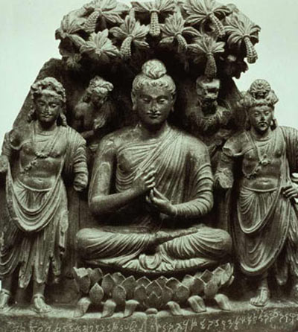
The Mauryan Empire reached its peak under Ashoka (271-232 BCE), Chandragupta’s grandson. Apparently, Ashoka began his rule as a ruthless autocrat. Legend says that he killed 99 of his brothers in order to secure the throne for himself. Eventually, he seems to have had a change of heart. According to a stone pillar erected and inscribed by Ashoka himself, he rejected bloodshed after witnessing an especially bloody battle. He then turned to Buddhism, a religion that had been developing in northern India since the time of its founder, Siddhartha Gautama.

Buddha agreed with Hinduism that people’s destiny depended on how they lived their lives. He did not, however, see a need for Hindu gods, priests, temples, or the sacrificing of animals. Buddha stressed a code of ethics based on unselfishness and on rules of behavior that he called the Eightfold Path. A person simply had to live a moral, unselfish life in order to attain nirvana, the perfect peace which frees the soul from reincarnation (repeated rebirth of the soul until it attains perfection).
Buddha
en.wikipedia.org
Khajuraho temple
en.wikipedia.org

Ashoka considered himself responsible for the well-being of his subjects, and he tried to create a system of government based on non-violence, obedience to parents, tolerance of and respect for all opinions and sects, humane treatment of servants, kindness to all living beings, and generosity to all. He considered these principles so broad that no one, no matter his or her religious beliefs, could reasonably object to them. He announced these principles by carving them on rocks and stone pillars throughout his empire.

Decline/Fall
After Ashoka’s death in 232 BCE, the Mauryan Empire slowly disintegrated under a series of weak leaders. It came to an end around 184 BCE with the assassination of the last emperor.

provinces, districts, and villages: similar to cities and states today
swift: fast
elaborate: complicated
regulated: controlled
turrets: towers setup along city walls from which army men could protect the city
erected: built
Inscribed: to carve words onto something

Source: http://worldhistoryforusall.sdsu.edu/units/four/landscape/Era04_landscape4.php

Map of Mauryan Empire
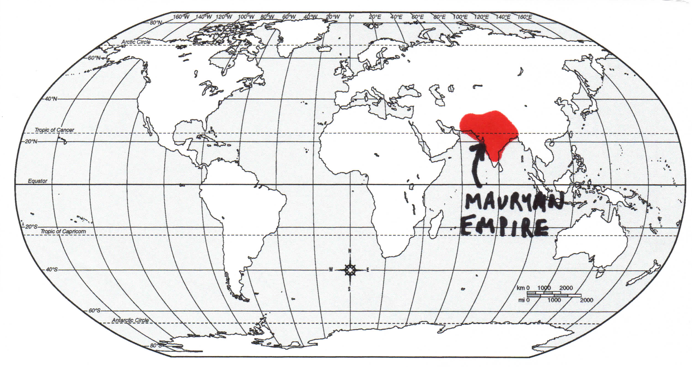
Document B: Alexander’s Empire, 330-323 BCE (Modified)

Founding
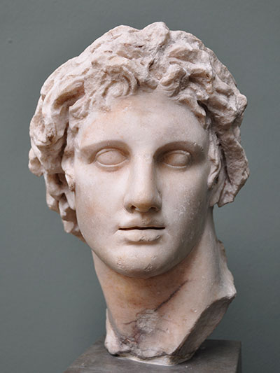
Philip, the king of Macedonia, intended to attack Persian-ruled Anatolia, but he was assassinated before he could take action. He was succeeded by his son, Alexander, barely twenty years old. Alexander had been educated by the Greek philosopher Aristotle and trained in politics and war by his father. He was tireless in battle, a stickler for details, and conscious of his image. He was adored by his soldiers and almost everyone else who met him.

In 334 BCE, Alexander attacked Persia leading an army of 35,000 Macedonians and Greeks. In the course of the next eleven years, he moved through Anatolia, Syria, Egypt, and Babylonia, conquering as he went. He faced the Persians in three major battles and won each against huge odds. He took control of the great Persian capitals. In 326 BCE, he turned southeast and pushed his exhausted troops into the Indus valley. There, he took control of one local ruler after another. When he asked his troops to go on beyond the Indus, they refused. He saw that they could be pushed no further and agreed to head home. In 330 BCE, Alexander was in possession of a gigantic Indo-Mediterranean empire.
Bust of Alexander the Great
blog.oup.com

Administration
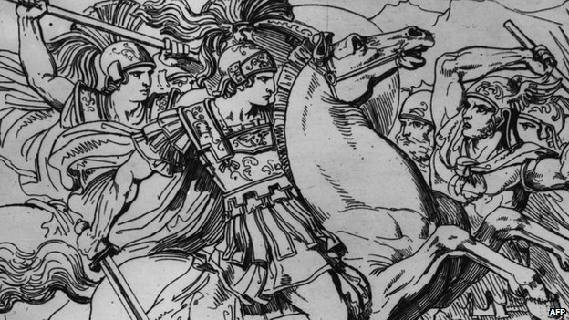
Alexander was undoubtedly a conqueror and destroyer. For example, he demolished the Greek city of Thebes, and he allowed his solders to destroy the Persian capital of Persepolis, killing the men, enslaving the women, and taking the city’s treasure. Alexander, however, was also a builder. He was charmed by Greek culture and an admired the Persian’s skill at controlling an empire.

Everywhere, he established new cities in the Greek style and filled them with ex-soldiers who settled down and formed an elite class. Most of these Greeks married local women and raised half-Greek, half-Persian children who grew up speaking Greek. Alexander held a gigantic marriage ceremony, wedding thousands of his soldiers to Persian women.
Alexander’s Army
www.bbc.com

Religion
Alexander’s mother once told him that his real father was not Phillip but Apollo, a Greek god. Eventually, Alexander had himself recognized as the Pharaoh, whom Egyptians considered to be godlike.

As he achieved more victories his reputation grew, Alexander seemed to become more convinced of his godlike roots. At one point, he required that his subjects adore him as a godlike figure. His Greek court and soldiers refused to do this, so he dropped the issue. He did, however, promote his relationship to the gods by putting his own likeness on the front of coins and the image of Zeus, a Greek god, wielding a thunderbolt on the back. During his lifetime, several religious cults who worshipped Alexander as a god appeared, though they disappeared shortly after he died.

Decline/Fall
Alexander died in June 323 BCE. He appears to have died of a fever complicated by a number of factors: wounds he had suffered in the course of battles, overwork, a hunting trip in mosquito-ridden swamps, and a heavy night of drinking. He lingered for four days, and when his generals desperately urged him to name an heir, he is said to have replied that it would go to the strongest. In fact, after his death, his generals almost immediately started wars against one another, resulting in the division of the empire into three major military states. Alexander asked to be buried in Egypt, and reportedly his body was taken there in a golden sarcophagus (coffin). But no one knows where the conqueror’s remains were laid.

assassinated: when an important person is murdered
adored: loved
against huge odds: he was expected to lose
pharaoh: an Egyptian ruler who was also considered to be a god
heir: the next leader

Source: http://worldhistoryforusall.sdsu.edu/units/four/landscape/Era04_landscape4.php

Map of Alexander’s Empire

