Document A: The Persian (Achaemenid) Empire, 550-330 BCE

Formation
It took Cyrus II, the leader of the Achaemenids, which was one of these Persian clans, less than a decade to conquer the Medes. He then moved on to seize control of the Anatolian Peninsula and the Greek city-states settled along the peninsula’s western edge. Syria was next and in 539 Babylon fell as well.

When conquering Babylon, Cyrus had promised to treat it fairly and not to destroy either its customs or its culture. At the same time, he returned the items that were taken by the Babylonians through conquests to their rightful owners. Cyrus also freed the Hebrews, who had been enslaved in Babylon. He allowed them to return home. Later he helped them rebuild their temple in Jerusalem. This policy of local cultural independence won him a reputation as a fair ruler.

Meanwhile, other Persian forces moved northeast into the rich lands of Bactria-Sogdiana where they captured most of the trade centers on the Silk Routes that led to Inner Eurasia. After Cyrus’ death, his son, Cambyses, conquered Egypt. In 322 BCE, Cambyses died. Darius (522-486 BCE), a strong military leader, took control. He pushed the Persian borders to the Indus River valley in the east. The Persians now controlled the largest empire the world had ever seen.

Administration
The vast Persian Empire was the most culturally diverse empire that had ever existed. It linked the east with the west and ruled cities where people of every class and culture rubbed shoulders and shared ideas. It was a huge meeting of cultural and social sharing. To rule it, the Persians had to invent new governmental tools.

It was Darius I who, building on the governmental systems inherited from the Assyrians and Babylonians, reorganized the empire. He established twenty provinces (called satrapies), each with its governor, military commander, and treasurer, who reported separately to the king. In addition, there was a separate system of inspectors known as the “King’s Eyes” or the “King’s Ears.” These inspectors had their own armies and could move against even a military commander if necessary. The system was so effective in preventing rebellion, corruption, and harsh rule that it was copied again and again, even in modern times.

Darius also introduced the Babylonian calendar, known for its accuracy, and set up granaries to assure a constant supply of food for his troops. He built elaborate underground irrigation systems as well. In the far reaches of what is now Iran, these irrigation systems turned deserts into gardens.

Religion
The Persian ruling class followed the religion of Zoroastrianism. This religion taught that there were two deities, Ahura Mazda, the god of light and truth and Ahriman, the god of darkness and evil. These two gods were in constant struggle, a struggle that Ahura Mazda would eventually win. Zoroastrians believed that after the final battle, there would be a Judgment Day and everyone who had ever lived would be judged and sent either to heaven or hell. These ideas are believed to have influenced Judaism, Christianity, and Islam. Today, there are Zoroastrians communities in Iran and India, where they are called Parsis or Parsees. Communities also exist in other parts of the world including the United States. The Achaemenids did not force Zoroastrianism on their people. As rulers of an empire that embraced more cultural communities than anyone before them, they wisely allowed their subjects cultural freedom.
diverse: different; distinct; various
class (i.e. social class): different groups within a society separated by economic and social status
granaries: a place to store grains for making food
deities: gods

Source: http://worldhistoryforusall.sdsu.edu/units/four/landscape/Era04_landscape4.php
NOTE: This document has been modified in parts from the original.

The Persian Empire
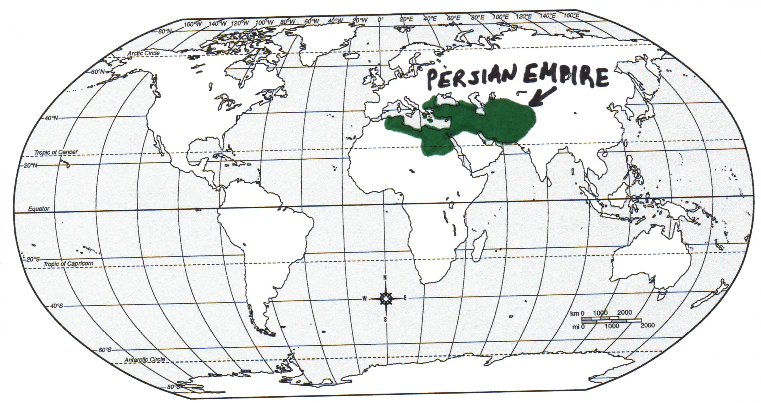

Document B: Profile of a Traditional Persian Woman in 450 BCE (Modified)

While most women of their time had little rights, Persian women enjoyed significant social and legal freedom. Available evidence about women in ancient Persia depends largely on social class. The higher the social status of a woman, the more information there is likely to be found pertaining to her. Royalty or nobility gave women the highest social status, with the top-ranking woman in the Persian Empire being the king’s mother. Next came the wife and sisters of the king. Working women were part of the middle class. The Greek writer Plutarch states that Persian armies employed women soldiers. Others specialized as artisans. Women, like men, received wages and were praised for their good work. Sometimes men and women had the same job and worked together. Conversely, some jobs were done only by one gender. Records show that in ancient Persia gender did not dictate who had more power. For example, women could be managers of a workshop and thereby hold a higher position than a man. No lower class is documented in Persian records, only two divisions of royalty and aristocracy and one division making up the ordinary working class.

Because some women earned their own wages, they enjoyed an economic freedom unknown to many women in the ancient world. Women were able to own land and manage their estates, even if they were far from home. These estates housed people who worked the land and paid a tax to the woman landowner. Because she controlled her own money, she was able to use it as she wished. At times, women would host excessive parties, and they bought their own wine and food for their guests. They could also choose who inherited their money. It did not automatically become the property of their husbands.

Ancient Persia, however, was a patriarchal system, meaning that it gave certain privileges to men. Though women had the power to become rulers if their husbands died or to initiate a divorce, they could not have more than one husband. A husband, however, could have several wives. Women could not be witnesses to legal contracts. A man had to be present whenever a contract was signed. Men also had substantial control over their children. If the family had debt, the children could be sold.

Though the Persian Empire was large, women had more freedom than in other parts of the ancient world. Slight differences in rights occurred throughout the empire, but generally each gender was seen as socially and economically equal.

royalty or nobility: the most important people and leaders of a society
artisans: a worker who works in a particular job such as blacksmith, artist, etc.
estates: a land or property that is owned by someone

Principal Source: Pars Times, http://www.parstimes.com/women/women_ancient_persia.html
Additional Source: http://worldhistoryforusall.sdsu.edu/units/four/landscape/Era04_landscape4.php

NOTE: This document has been modified in parts from the original.

Document C: Atossa, Mother of Emperor Xerxes (Modified)

In ancient Persian tradition, successors inherited not only the throne of the king but also his family. And so it was that when Cyrus died attacking the Scythians, his son Cambyses assumed the throne and responsibility for Cyrus’ family. Cambyses was a wild and wicked ruler, and he ended up killing his own brother to keep him from gaining power…After his death, Darius, a Persian official, came to power. In accordance with tradition, he took on Cambyses’ family. He married Cambyses’ sister Atossa, who then convinced him to invade Greece.

Atossa suffered from an illness and was cured by a prisoner, who was a Greek physician. As payment, he asked to be returned to his native country. Atossa agreed to try to persuade Darius to allow this. She approached the king by stating that an invasion of Greece would extend the glory of the Persian Empire. Darius had been planning to invade the territory of the Scythians by making a bridge across the Hellespont. He felt this would show his power in succeeding where Cyrus had failed. Atossa, however, impressed upon him that the Greeks were a more sophisticated people than the Scythians and that conquering them would be a greater accomplishment.

A group was sent to explore Greece and bring back a report. The physician went on the expedition, escaped, and never came back. Meanwhile, the commission brought back a favorable report, and Darius planned to attack Greece. Before the invasion, however, it was necessary to assign an advisor. Darius had two sons. Xerxes was the oldest son of Atossa and Darius. But Darius also had an older son, Artobazanes, from the time before he took the throne. Atossa argued that Xerxes was the grandson of Cyrus and therefore had a direct bloodline to the throne. Darius could not claim such a bloodline, and this may have hurt his pride. So Xerxes, not Darius’ older son and heir, assumed the throne. Atossa’s reasoning, however, could not be denied. Darius was also told that because he was king when Xerxes was born, Xerxes was therefore the son of a king, while Artobazanes was only the son of Darius the official. Consequently, Darius’ older son was passed over, and Xerxes was made heir to the throne.

successors: the next person in line to take the throne
sophisticated: complicated

Principal Source: Herodotus, The Histories, trans. Robin Waterfield (Oxford: Oxford UP, 1998).

Additional Source: http://worldhistoryforusall.sdsu.edu/units/four/landscape/Era04_landscape.php

NOTE: This document has been modified in parts from the original.

Document D: Esther, Wife of Emperor Xerxes (Modified)

King Xerxes held a feast lasting 180 days to display the wealth of Susa, his finest capital. During the festivities, Xerxes called for the queen, Vashti, to perform for his guests. However, Vashti refused to join the feast. Angered, Xerxes banished her from the palace, thereby showing that women had to obey their husbands and should be punished for their disobedience. In the years following the feast, Xerxes led a rebellion in Babylon and an invasion of Greece. When he returned to Susa in 480 BCE, he began to search for a new wife. He appointed commissioners in every province to bring beautiful women to the citadel in Susa.
In the city of Susa, there was a group of about 100 Jews. Mordecai, one of the Jews, worked for Xerxes. Mordecai’s cousin, Esther, was taken to the citadel to become a candidate for queen. Before she left, Mordecai told her to keep her religion a secret, and Esther promised she would tell no one. For twelve months, Esther and the other young women who had been assembled at the citadel were given beauty treatments and special food to prepare them for their meeting with Xerxes. When the time came for the king to choose a new wife and queen, he chose Esther and placed the crown on her head.
Some time later, Xerxes selected the nobleman Haman to be the vizier, or chief minister, of the empire. Everyone at the city gates bowed down to Haman except one man, Mordecai. Being a Jew, Mordecai believed that there was only one God and that only God should be worshipped. This enraged Haman, yet day after day Mordecai continued to disobey the order to bow before Haman. Finally, Haman was told that Mordecai was Jewish, and he began to look for a way to destroy all the Jews. He went to the king and said, “There is a certain people…in the provinces of your kingdom…who do not obey the king’s laws; it is not in the king’s best interest to tolerate them. If it pleases the king, let a decree be issued to destroy them …” King Xerxes allowed Haman to carry out his plan.
Mordecai, however, heard of the plan and asked Esther to go to Xerxes. Esther decided to try to save the Jews. After three days, Esther entered the king’s inner court, and when the king saw her, he was pleased with her and extended the golden scepter. Then the king asked, “What is it, Queen Esther? What is your request? Even up to half the kingdom, it will be given you.” Esther very humbly said, “My petition and my request is this: …let the king and Haman come tomorrow to the banquet I will prepare for them. Then I will answer the king’s question.” The king agreed, and for two days Haman and the king attended a banquet with Esther. Finally, on the second day, Xerxes asked again, “Queen Esther, what is your petition? It will be given you.” Queen Esther replied, “… [S]pare my people—this is my request. For I and my people have been sold for destruction.” “Who is he? Where is the man who has dared to do such a thing?” asked Xerxes. Esther replied, “The adversary and enemy is this vile Haman.”
Haman became terrified. King Xerxes got up in a rage and left the banquet room. Haman rushed to Esther to beg for his life, and at that moment the king returned. Immediately, he ordered that Haman be killed, and Esther was given all his estates. Haman’s orders to kill the Jews could not be revoked, however, because they had been stamped with the king’s signet ring. Instead, Xerxes allowed Mordecai to issue a new edict where the Jews could legally defend themselves. On the 13th and 14th day of Adar, the Jews throughout the Persian Empire defended themselves. Without Esther’s bravery, Jews throughout the Persian Empire would have faced destruction. Today, the Jews celebrate this victory by giving each other gifts and feasting during the holiday of Purim.

citadel: a fortress protecting a city
extended the golden scepter: he made her queen
estates: a land or property that is owned by someone

Principal Source: Adapted from Book of Esther, Holy Bible, New International Version, http://www.biblica.com/bible/verse/?q=Esther%202&niv=yes
Additional Source: World History for Us All. Landscape Era 4 (2014). http://worldhistoryforusall.sdsu.edu/units/four/landscape/Era04_landscape4.php
NOTE: This document has been modified in parts from the original.
Document E: Artemisia I, a Naval Commander (Modified)

In 499 BCE, Athens supported an uprising of the Ionian Greek city-states in Asia Minor. The Ionian city-states were part of the Persian Empire, and Darius the Great put down the revolt. He later attacked Greece for Athens’ involvement in the rebellion. Darius was defeated at the Battle of Marathon, and about twenty years later, his son Xerxes, attacked Greece again. This time, Queen Artemisia I commanded five ships in Xerxes’ navy.

Before Xerxes’ attack on Greece, he questioned all of his admirals as to whether he should attack Salamis. All of his admirals urged him to attack, except Artemisia. Herodotus recorded in his Histories a supposed conversation between Artemisia and Xerxes. In this conversation, Artemisia reminded Xerxes that he had already accomplished what he had come to Greece to do and had burned Athens. That city-state had a superior navy, and Artemisia suggested that Xerxes keep his ships off the coast of Greece. Later, he could take the army onto the peninsula and attack on foot. She had heard that there were no supplies on the Peloponnesus and, if they attacked there, the Greeks would not likely defend Athens. Though this was not a popular idea, Artemisia voiced her opinion. Instead of being upset with her, Xerxes was pleased. He chose, however, to follow the advice of his other admirals. During the Battle of Salamis, Artemisia became surrounded and trapped by ships. She rammed one of the ships in an attempt to save the lives of her crew. Cleverly, she purposely hit a ship of Calyndia, an ally of Persia. The Athenians thought Artemisia’s ship must be Athenian since she had destroyed their enemy’s ship. So they stopped pursuing her. When the Athenians discovered that they had been outsmarted by a woman, they offered a reward for her capture.

After the Battle of Salamis, Xerxes convened his admirals once more. Mardonius, one of his generals, urged Xerxes to stay and fight. This time, however, Xerxes specifically asked Artemisia for advice. She urged him to depart from Greece and leave Mardonius in charge of some troops. If Mardonius lost the battle, Xerxes would be safe back in Persia, and he still would have had revenge on Athens by burning it to the ground. If Mardonius won, Xerxes would be praised because he appointed Mardonius. This time, Xerxes took Artemisia’s advice. Xerxes went back to Persia, and after months of fighting, Mardonius was killed and the last of the Persians were defeated in Greece.

Many stories surround what happened to Artemisia. No one knows for sure what happened to her, but her grandson eventually became ruler of Halicarnassus.

uprising: an act of rebellion
admirals: a leader in the navy

Principal Source: Herodotus, The Histories, trans. Robin Waterfield (Oxford: Oxford UP, 1998).

Additional Source: http://worldhistoryforusall.sdsu.edu/units/four/landscape/landscape4.php

NOTE: This document has been modified in parts from the original.

