Chapter 2 Study Guide

____ 1. Which organic molecules below are most closely related to lipids?
a. | sugars | c. | amino acids
b. | fatty acids | d. | nucleotides

____ 2. The smallest particle of matter that can retain the chemical properties of carbon is a(n)
a. | carbon macromolecule. | c. | carbon molecule.
b. | element. | d. | carbon atom.

____ 3. Nonpolar molecules have
a. | only a positive pole. | c. | only a negative pole.
b. | no negative or positive poles. | d. | both negative and positive poles.

____ 4. The electrons of an atom
a. | are attached to the positive charge of neutrons.
b. | are found in the nucleus along with the protons.
c. | have a positive charge.
d. | occupy the space surrounding the nucleus.

____ 5. Which of the following organic molecules are classified as carbohydrates?
a. | fatty acids | c. | sugars
b. | nucleotides | d. | amino acids

____ 6. Atoms are composed of
a. | electrons. | c. | neutrons.
b. | protons. | d. | All of the above

____ 7. A chemical formula shows the
a. | kinds of bonds found in the molecule.
b. | kinds of elements found in the compound.
c. | arrangement of the elements found in the compound.
d. | kinds of bonds found in the compound.

____ 8. Which of the following organic molecules are most closely related to nucleic acids?
a. | amino acids | c. | nucleotides
b. | fatty acids | d. | sugars

____ 9. The two strands of a DNA molecule are held together by
a. | covalent bonds. | c. | hydrogen bonds.
b. | ionic bonds. | d. | None of the above

____ 10. Carbohydrates and lipids have many carbon-hydrogen bonds; therefore, they both
a. | dissolve only in vinegar. | c. | are easily dissolved in water.
b. | store energy in these bonds. | d. | exist only in cells of plants.

____ 11. Which of the following is not an organic macromolecule?
a. | carbohydrate | c. | lipid
b. | ice | d. | nucleic acid

____ 12. Reducing activation energy
a. | requires higher temperatures than those found within cells.
b. | is accomplished by the action of catalysts on reactants.
c. | occurs only when reactants are quickly added to the reaction mixture.
d. | is a violation of the laws of nature.

____ 13. Acidic solutions have a pH that is
a. | more than 7. | c. | less than 7.
b. | a negative number. | d. | between 7 and 14.

____ 14. Lipids are soluble in
a. | water. | c. | oil.
b. | salt water. | d. | All of the above

____ 15. Water is important to life because it
a. | surrounds all cells.
b. | is found inside cells.
c. | influences the shape of the cell membrane.
d. | All of the above

____ 16. The two types of nucleic acids are
a. | chlorophyll and retinal. | c. | DNA and RNA.
b. | lipids and sugars. | d. | glucose and glycogen.

____ 17. All matter is composed of
a. | atoms. | c. | carbon.
b. | molecules. | d. | cells.

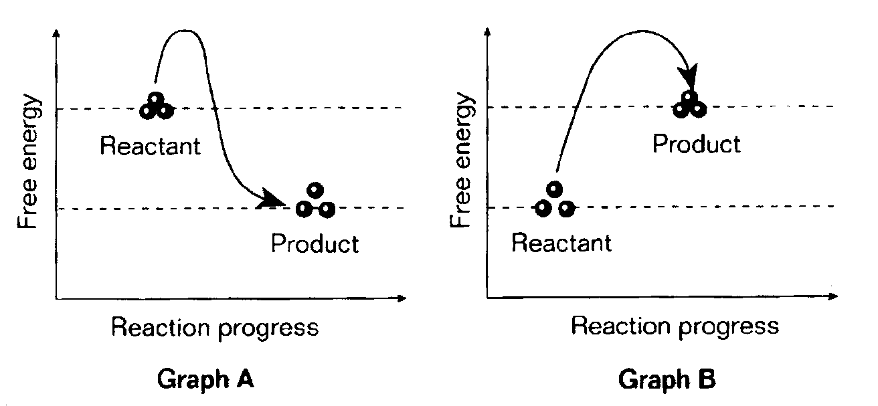

____ 18. Refer to the illustration above. Which graph illustrates what happens during an energy-releasing reaction?
a. | both graphs because they each show a different stage of an energy releasing reaction
b. | Graph A
c. | Graph B
d. | None of the above

____ 19. Refer to the illustration above. Which graph illustrates a reaction during which energy is released?
a. | Graph B
b. | Graph A
c. | both graphs because all chemical reactions release energy
d. | None of the above

____ 20. Due to the polarity of water, compounds that dissolve best in water contain
a. | nonpolar bonds. | c. | polar bonds.
b. | ionic bonds. | d. | Both (b) and (c)

____ 21. An enzyme
a. | is not used up when catalyzing a reaction.
b. | bonds with a substrate molecule at the enzyme’s active site.
c. | lowers the activation energy of a reaction.
d. | All of the above

____ 22. Which of the following is a carbohydrate?
a. | DNA | c. | glucose
b. | insulin | d. | wax

____ 23. Water is a polar molecule because
a. | it contains two hydrogen atoms for each oxygen atom.
b. | it has a charge.
c. | it does not have a charge.
d. | different parts of the molecule have slightly different charges.

____ 24. A substance that is composed of only one type of atom is called a(n)
a. | molecule. | c. | cell.
b. | element. | d. | nucleus.

____ 25. Which of the following organic molecules are most closely related to proteins?
a. | amino acids | c. | nucleotides
b. | fatty acids | d. | sugars

____ 26. A molecule shaped like a spiral staircase (double helix) is typical of
a. | lipids. | c. | deoxyribonucleic acid.
b. | carbohydrates. | d. | All of the Above

____ 27. When placed in the same container, oil and water do not mix because
a. | they are both polar. | c. | water is polar and oil is nonpolar.
b. | they are both nonpolar. | d. | water is nonpolar and oil is polar.

____ 28. Which of the following conditions affects the function of enzymes?
a. | enzyme concentration | c. | pH
b. | heat | d. | All of the above

____ 29. A cell contains
a. | approximately 100 kinds of enzymes, each promoting a different chemical reaction.
b. | thousands of different kinds of enzymes, each promoting a different chemical reaction.
c. | one kind of enzyme that promotes thousands of different chemical reactions.
d. | one enzyme that promotes photosynthesis and one enzyme that promotes cellular respiration.

____ 30. DNA stores
a. | carbohydrates. | c. | fat.
b. | heredity information. | d. | protein.

____ 31. Enzymes
a. | always provide carbon dioxide for chemical reactions.
b. | absorb excess heat so that reactions occur at low temperatures.
c. | are able to heat up molecules so that they can react.
d. | are biological catalysts.

____ 32. Long chains of amino acids are found in
a. | lipids. | c. | carbohydrates.
b. | proteins. | d. | sugars.

____ 33. All of the following are examples of lipids except
a. | saturated fats. | c. | starch.
b. | earwax. | d. | cholesterol.

____ 34. Ionic bonds form between molecules that have
a. | neutral charges. | c. | no charges.
b. | the same charge. | d. | opposite charges.

____ 35. A molecule that has a partial positive charge on one side and a partial negative charge on the other side is called a
a. | bipolar molecule. | c. | nonpolar molecule.
b. | polar molecule. | d. | charged molecule.

____ 36. Lipids are
a. | water soluble. | c. | nonpolar molecules.
b. | similar to water molecules. | d. | polar molecules.

____ 37. Animals store glucose in the form of
a. | lipids. | c. | wax.
b. | cellulose. | d. | glycogen.

____ 38. The bond formed when two atoms share a pair of electrons is called a(n)
a. | hydrogen bond. | c. | ionic bond.
b. | water bond. | d. | covalent bond.

____ 39. The molecule on which an enzyme acts is called a(n)
a. | active site. | c. | substrate.
b. | organic molecule. | d. | inactive site.

____ 40. All organic compounds contain the element
a. | calcium. | c. | nitrogen.
b. | sodium. | d. | carbon.

____ 41. Sharing of electrons in the outer energy levels of two atoms
a. | results in ion formation.
b. | only occurs if both are atoms of the same element.
c. | occurs in covalent bonds.
d. | is found only among carbon atoms.

