**Chu Cuoi, the Moon Man Folktale (from Vietnam)**

In Vietnam the [Mid-Autumn Festival](http://www.holidaysia.com/events/mid-autumn-festival/), known as Tet Trung Thu in Vietnamese, is the country’s second most important holiday, after [Tet](http://www.holidaysia.com/events/tet/), the Vietnamese New Year. Tet Trung Thu usually takes place on the 15th day of the 8th lunar month. In 2013 it will be on September 19.

The traditions surrounding this holiday date back thousands of years, and they place a huge emphasis on children. It is thought that the festival was originally celebrated to give parents time to catch up with their children after the summer harvest was completed. People also believed that children were innocent and pure, and thus were the closest connection to the sacred and natural world.

Today, the approach of Tet Trung Thu is signaled by the appearance of stands selling banh trung thu, or mooncakes, all over Vietnam’s streets. These cakes are very rich and are filled with lotus seeds, ground beans, and an egg yolk, though there are other varieties. Mooncakes are the most important traditional food related to Tet Trung Thu, and they are massively popular.

[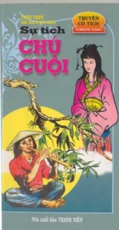](http://talk.onevietnam.org/wp-content/uploads/2010/09/1804.jpg)Tet Trung Thu: During this time, families will get together just for the sake of being together and enjoying the season. Parents who normally work full time and hardly get to see their children, will take time off and spend more time with their children by making paper lanterns together, singing songs, eating Banh Trung Thu (mooncakes), singing Karaoke, and sharing stories about life, stories of legend, stories that present myths, etc. This is a precious time for older generations to pass on their knowledge of culture to the younger generations as it had been done for them. This tradition becomes a medium for how culture is preserved and traditions are passed on from older generations to younger ones. Oral traditions are significant and the fact that they are in the native tongue makes them much more precious.

During the Mid-Autumn Moon time period, children hear about Chu Cuoi, the Moon Man. I have heard the story told as such, but in Vietnamese of course! Chu Cuoi is a woodcutter who found a tiger cub in the forest one day. He followed the baby cub because he wanted to catch it and raise it since it was all alone. He grabs the baby tiger and suddenly the mother tiger comes out of nowhere, searching for her baby. Chu Cuoi becomes afraid and begins to climb a tree with the cub in his arms. He accidentally drops the baby cub and it falls onto it’s head. Chu Cuoi starts to cry, for he feels bad about the death of the baby cub but he watches the mother tiger walk towards the bay. She rips off some leaves from a tree and brings it back to her cub. She rubs the leaves onto the cubs head and he is healed! Chu Cuoi witnesses this and becomes determined to keep the tree for himself. He goes over to the bay and digs up the tree to bring back to his home. Chu Cuoi advises his wife to water the tree everyday while he is away at work. Since the tree is special, he makes sure to tell her that she must use the water from the well. One day the wife forgets to water the tree and sees her husband coming home from work. She has no time to gather well water so she begins to urinate on the tree. The magical tree becomes angry, and begins to fly away. Chu Cuoi sees the tree ascending into the sky and hurriedly rushes to seize the roots and hold it back. The magical tree ends up pulling Chu Cuoi to the moon. It is said that his image holding onto the root of the tree on the moon can be seen during mid-autumn festival.

[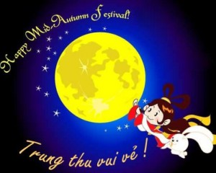](http://talk.onevietnam.org/wp-content/uploads/2010/09/00.jpg)

Reflection: on a **separate** sheet of paper, answer the following:

1. What is your favorite holiday and why? Explain any family traditions for this holiday.

2. What are some foods that you associate with certain holidays. List the food and the holiday. If it’s a food we wouldn’t know, please give a brief explanation.

3. How would you celebrate Tet Trung Thu with your family and/or friends?