Name:___________________________________Date:_________________ Period:_______________
Do now – complete on back of this sheet
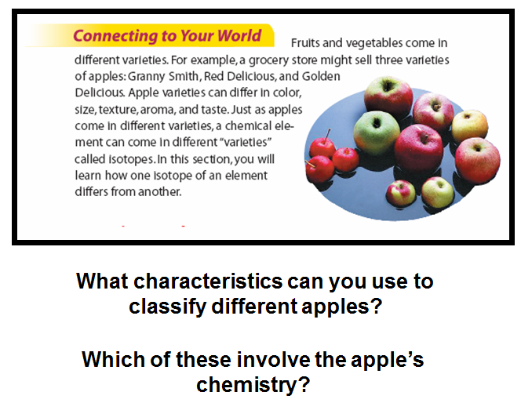

Name:___________________________________Date:_________________ Period:_______________
Do now – complete on back of this sheet

