Name:__________________________________________Date:__________________Period___________
Find the average atomic mass given the percentages of each isotopes of the atoms. Remember significant figures and to label the units.
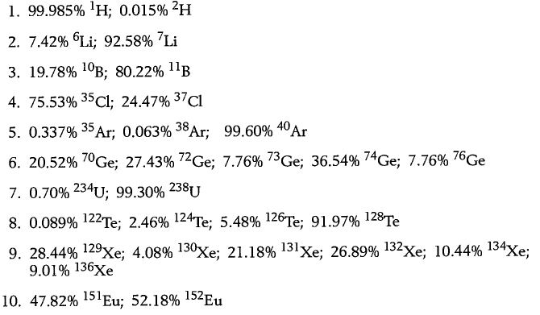
Name:__________________________________________Date:__________________Period___________
Find the average atomic mass given the percentages of each isotopes of the atoms. Remember significant figures and to label the units.

