**Temperature, Precipitation, and Biome Distribution**

**Purpose:**

The purpose of this lab is to construct and analyze a **climatogram**, and describe the relationship between the amount of rainfall and variance of temperature to the effect of the distribution of biomes globally.

**Background**:

**Weather** is a local area’s short-term temperature, precipitation, humidity, wind speed, cloud cover, and other physical conditions of the lower atmosphere. **Climate**, on the other hand, is a geographic area’s pattern of atmospheric or weather conditions over long periods of time. Average temperature and average precipitation are the two main factors determining climate, along with **latitude** (distance from the equator) and **altitude** (distance above sea level).

**Biomes** are large terrestrial regions characterized by similar climate, soil, plants, and animals, regardless of where they are found in the world. Biomes are closely associated with climate. You can easily associate the climate of your own locality with the biome found there. Only by extensive travel, however, can the close relationship of particular climates with particular biomes be learned on a worldwide basis. This exercise is a poor substitute for such travel; but if it is carried out thoughtfully and with frequent reference to the description of biomes in the text, it can help you understand the biological relationships that make up the diversity of the biotic communities found on land.

Below you will find six examples of climatograms, grids on which averages of precipitation and temperature at a particular location are plotted together. These climatograms show variations in only two important climatic factors during a year. Other factors may greatly affect climate, but a climatogram does give a rough idea of climate in the location from which the data were obtained.

Part 1: Identification of Temperature and Precipitation of Biomes: Using your textbook below, fill in the average temperature and precipitation of each of the biomes listed:

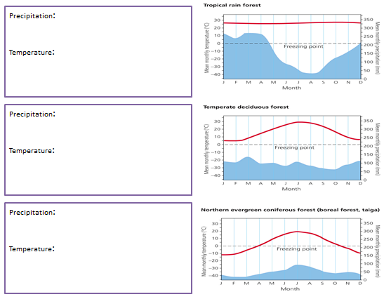

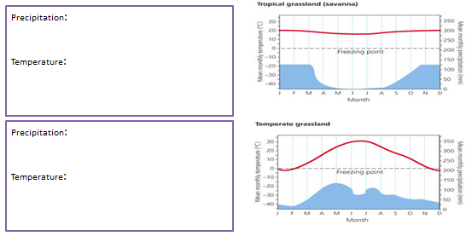

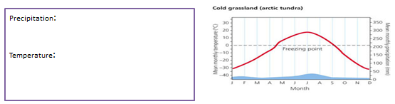

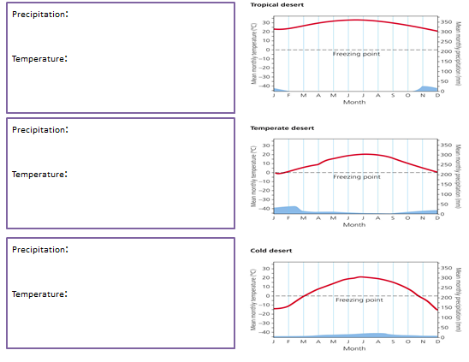

Part 4: Based on the attributes listed below, name which biome is best described. The graph below will assist you in this task.

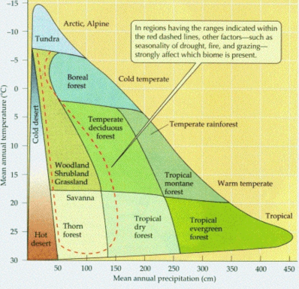

|  |  |
| --- | --- |
| **Which of the biomes has:** | **Biome Name:** |
| **Most Rainfall** |  |
| **Least Rainfall** |  |
| **Highest Average Temperature** |  |
| **Lowest Average Temperature** |  |
| **Most Consistent Year-Round Temperature** |  |
| **Most Variable Year-Round Temperature** |  |

Part 4: Climatographs: Create a Climatograph using Microsoft Excel

1. Open a Microsoft Excel Sheet
2. Type or copy the following information on three cities of the world and their biomes.

|  |  |  |  |  |  |  |  |  |  |  |  |  |
| --- | --- | --- | --- | --- | --- | --- | --- | --- | --- | --- | --- | --- |
| Cuiaba, Brazil: Tropical Seasonal Forest | | | | | | | |  |  |  |  |  |
|  | J | F | M | A | M | J | J | A | S | O | N | D |
| P: | 24.9 | 21.1 | 21.1 | 10.2 | 5.3 | 0.8 | 0.5 | 2.8 | 5.1 | 11.4 | 15 | 20.6 |
| T: | 27.2 | 27.2 | 27.2 | 26.6 | 25.6 | 23.9 | 24.4 | 25.6 | 27.8 | 27.8 | 27.8 | 27.2 |
|  |  |  |  |  |  |  |  |  |  |  |  |  |
| 2) |  |  |  |  |  |  |  |  |  |  |  |  |
| Santa Monica, California: Temperate Woodland and Shrubland | | | | | | | | | | | |  |
|  | J | F | M | A | M | J | J | A | S | O | N | D |
| P: | 8.9 | 7.6 | 7.4 | 1.3 | 1.3 | 0 | 0 | 0 | 0.3 | 1.5 | 3.5 | 5.8 |
| T: | 11.7 | 11.7 | 12.8 | 14.4 | 15.6 | 17.2 | 18.9 | 18.3 | 18.3 | 16.7 | 14.4 | 12.8 |
|  |  |  |  |  |  |  |  |  |  |  |  |  |
| 3)  Moshi, Tanganyika: Tropical Savanna | | | | | | | |  |  |  |  |  |
|  | J | F | M | A | M | J | J | A | S | O | N | D |
| P: | 3.6 | 6.1 | 9.2 | 40.1 | 30.2 | 5.1 | 5.1 | 2.5 | 2 | 3 | 8.1 | 6.4 |
| T: | 23.3 | 23.2 | 22.2 | 21.1 | 19.8 | 18.4 | 17.9 | 18.4 | 19.8 | 21.4 | 22 | 22.4 |

1. In a Climatograph the Precipitation is a column graph and temperature is a line graph.

* Highlight data
* Insert – chart- 2D clustered column
* Right click temp on graph
* Change data series chart type to line graph
* Right click left hand scale
* Format axis- change scale (0-36)
* Right click temp
* Format data series – secondary axis
* Right click right hand scale
* Format axis – change scale (-36 to 36)

Part 4 – In this next section, we will be examining the relationships between elevations (altitudes) and land biomes. The following Locations A, B and C are of the **SAME LOCATION at DIFFERENT ALTITIDTES** like on a mountain.

|  |  |  |  |  |  |  |  |  |  |  |  |  |
| --- | --- | --- | --- | --- | --- | --- | --- | --- | --- | --- | --- | --- |
| Location A | |  |  |  |  |  |  |  |  |  |  |  |
|  | J | F | M | A | M | J | J | A | S | O | N | D |
| P: | 3.8 | 3.6 | 5.6 | 6.6 | 9.9 | 11.4 | 9.4 | 8.6 | 10.2 | 6.4 | 4.8 | 3.8 |
| T: | -6.7 | -5 | 1.7 | 9.4 | 15.6 | 21.1 | 23.9 | 22.2 | 17.8 | 11.1 | 2.8 | -3.9 |
|  |  |  |  |  |  |  |  |  |  |  |  |  |
| Location B | |  |  |  |  |  |  |  |  |  |  |  |
|  | J | F | M | A | M | J | J | A | S | O | N | D |
| P: | 1.3 | 1.6 | 2.8 | 6.1 | 9.9 | 10.3 | 6.5 | 5.2 | 6.1 | 3 | 2.1 | 1.5 |
| T: | -4.6 | -1.9 | 2.6 | 9.9 | 15.8 | 21.8 | 25.7 | 24.4 | 18.9 | 12.2 | 3.3 | -2.2 |
|  |  |  |  |  |  |  |  |  |  |  |  |  |
| Location C | |  |  |  |  |  |  |  |  |  |  |  |
|  | J | F | M | A | M | J | J | A | S | O | N | D |
| P: | 1.3 | 0.8 | 2 | 2.5 | 3.8 | 3.1 | 4.3 | 3 | 2.5 | 2.3 | 1.3 | 1.3 |
| T: | -6.1 | -5.6 | -1.7 | 3.3 | 7.8 | 12.8 | 16.7 | 16.7 | 11.1 | 5 | -1.1 | -5.6 |

1. Describe how latitude influences precipitation and temperature.
2. What are the differences in precipitation and temperature between Locations A, B,C.
3. Which of the locations is the lowest elevation?
4. Which of the locations is the highest elevation?

Part 5 - Use the internet to find the average temperature and precipitation for your town.

a) Produce a graph summarizing this information. Got to weather.com enter zip code of your town or anywhere you like, Click monthly tab – scroll down to averages, change to table display to metric, use the mean temperature and average precipitation (change mm to cm).

b) What biome does your town belong to? Justify your answer.

**Conclusion and Discussion:**

***Please type your answers to all the questions below in complete sentences and hand them in with the excel graphs you generated above.***

1. How are the Tundra and Desert similar? How are they different?

2. How are the Tropical Rain Forest and Tropical Seasonal Forest similar? How are they different?

3. Lawrence, Kansas and Nashville, Tennessee occupy similar latitudes. Why is one found in Temperate Grassland and the other in a Temperate Forest biome?

4. How are periods of drought reflected on a climotograph?

5. What factors can change precipitation and temperatures in an area?

6. What limitations are there to the data? (How accurate is the data? What problems will skew your results?)

**References:**

http://www.geocities.com/Athens/Parthenon/1020/bioweb.html