I. Plant Growth
A. Stems
1. Grow from their tips due to the apical meristem
a. the area behind apical meristem is the zone of elongation
b. the area behind the zone of elongation is the zone of maturation

B. Roots
1. Root cap – designed to protect the apical meristem from damage
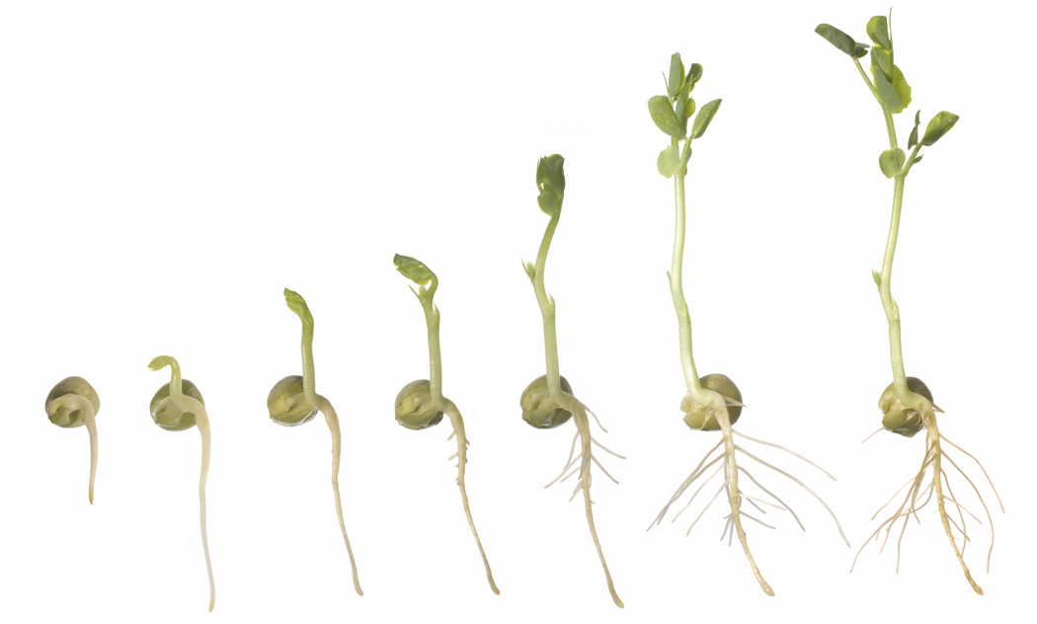
a. pushes forward due to the action of apical meristem
1. Apical meristem triggers cells to divide at the tip.
2. zone of elongation - directly behind the apical meristem
3. zone of maturation - beyond the zone of elongation

II. Seed Germination
A. Germination – state when seeds leave dormancy an actively begin to grow
1. Imbibition – Process where seeds absorb water before germination
2. Scarification – Scratching or nicking the seed coat to induce germination

B. Early Growth
1. Coleoptile – Surrounds the young shoot in monocots
2. Indeterminate growth – Ability of certain parts to grow indefinitely.
1. Characteristic of stems and roots.
3. Determinate growth – Parts of a plant stop growing after reaching a certain size.

C. Quiescence – occurs when seeds won’t germinate unless specific environmental
conditions are present.

III. Response to Light
- Photoperiodism
1. Any response plant exhibits to the relative lengths of daylight or darkness

B. Short-day plants (long-night plants)
1. Flower when the night length is equal to or greater than the critical length (vary
from species to species) for flowering.
2. Examples – Chrysanthemum, Asters, Ragweed, & Poinsettia

C. Long-day plants (short-night plants)
1. Flower when night length is equal to or less than the critical length
2. Examples – Clover, Spinach, Black-eye Susan, & lettuce

D. Intermediate-day plants
1. Flower when the day length is neither to long nor too short
2. Examples – Sugarcane and several grasses

E. Day Neutral Plants
1. Initiate flowering due to other stimulus and not the amount of daylight.
a. Vernalization is a response to temperature that affects flowering.
2. Tomatoes, dandelions, string beans, and pansies are day neutral.

IV. Responding to the Environment

A. Tropism – tendency to (move toward)
1. phototropism - growing toward light
2. gravitropism - growing downward in response to gravity
3. thigmotropism - response to touch
a. leads to vining or the recoil of the mimosa tree
4. hydrotropism - growing toward water

B. Plant Movements
1. Nuations – spiraling movements that occur as plants grow laterally (upward)
2. Nodding – movement that occurs in the bean family when the hypocotyl bends
(nods) like a pendulum as it pushes the cotyledon through the soil.
3. Twining – movement that occurs in tendrils that create obvious spirals to wrap
Around and cling to other structures for support.
4. Contraction – movement that occurs in the roots where stem tissue is pulled
Underground to serve as a food reserve; example: a bulb
5. Nastic – movement that occurs when flattened structures like leaves and
flower petals emerge from a bud and move down and then up as they
elongate to full size.
6. Turgor Movements – movements that result from changes in a plant’s water
pressure; leading to wilting, recovery, or sensitivity (thigmotropism)
7. Circadian Rhythms – Involves the time of the day as opposed to the time of year and
causes some plants to produce ‘sleep’ movements.
8. Solar Tracking – a twisting movement that occurs in leaves or flower heads so they
remain perpendicular to the sun.
9. Taxic Movements – movement that usually occurs in reproductive cells through
flagella or cilia.

C. Winter Dormancy - A response to the shortening of the length of the day
1. Can be triggered by and/or cause:
a. less auxin is produced in leaves
b. chemical changes to photochrome pigments
c. ethylene gas production increases causing fruit to ripen
d. protective bud scale form

V. Growth Hormones
A. Auxin (indoleacetic acid)
1. stimulates the elongation of stems and roots
2. migrates away from light
a. cells will elongate the side opposite the light; bending the plant toward the light.
b. causes roots to grow away from sunlight

B. Cytokinins
1. produced in the roots, but it migrates up the plant
2. inhibits the elongation of stems, causing them to grow thicker
3. responsible for the growth of lateral buds; especially if terminal buds are removed
4. causes the seed to sprout

C. Gibberellin
1. produced by parasitic fungus
- responsible for bolting in plants

D. Abscisic Acid
1. found in all plant material but is concentrated in fleshy fruits
2. prevents seeds from germinating
3. inhibits all cell division
4. helps leaves retain water during times of drought
5. production is usually increased during winter dormancy

