I. Characteristics of Fungus
A. Cellular Attributes
1. Cell Wall
a. composed of chitin (unlike plants which are mostly cellulose)
2. Reproduction
a. Asexual
1. budding - occurs in yeast (unicellular fungus)
2. spore formation (no genetic exchange)
b. Sexual
1. spore formation with genetic exchange

B. Attributes of Multicellular Fungus
1. Hyphae - masses of tiny individual filaments
a. septa - walls which divide some hyphae into segments
2. Mycelium - the ‘body’ of fungus formed from masses of tangled hyphae.
3. Pores - allow for passages of digestive enzymes, food, & gases
4. Spore Cases - holds the reproductive spores
5. Stipe - ‘stalk-like’ structure of mushrooms
6. Cap - specialized structure of mushrooms which covers & protect the spores
7. Gills - rows of ribbed structures under the cap which hold the spores
8. Annulus - ‘scar tissue’ left behind when the cap breaks free of the stipe to open &
release the spores.
II. Types of Fungus
A. Zygomycota - Common Molds
1. Structure
a. hyphae lack septums
b. possess specialized hyphae
1. rhizoids - ‘root-like’ structures which anchor & absorb food
2. stolons - connects groups of rhizoids to form a ‘body’
3. zygospore - specialized structure which give rise to sporangium
4. Sporangium - stalk which contains a rounded case which holds the spores

2. Specimens
a. Bread Mold (Rhizopus)

B. Ascomycota - Sac Fungus
1. Structure
a. very diverse group containing over 60,000 species
b. specialized sacs, called asci, form during sexual reproduction

2. Specimens
a. Yeast
b. Powdery Mildew
1. Dutch Elm Disease - See Plant Pathogen CD-Rom for details
a. Brought by Dutch settlers to the Americas on Apple Trees – which are not
native to America. The powdery mildew spread to elm trees which had no
natural immunity. The fungus nearly killed the entire elm population.

2. Ergot – See Plant Pathogen CD-Rom for details
a. Affects grains like rye or barley. Ingesting ergot can lead to severe illness
and/or hallucinations, and sometimes even death. Ergot may be responsible
for witch hunts and other superstitious practices as people did not
understand what was causing the hallucinations and irrational behavior in
people who accidentally ingested the ergot.

3. Blight – See Plant Pathogen CD-Rom for details
a. The primary cause for the Irish Potato Famine Ireland. A native crop of
America, potatoes had no immunity to blight which is commonly found in
Europe. The easily grown potato had long replaced other staple grains in the
Irish diet. When blight struck, entire fields were destroyed within days
leading to mass starvation among the Irish population.

C. Basidiomycota - Club Fungi
1. Structure
a. tend to be more likely to reproduce sexually
b. possess a stipe, cap, & gills

2. Specimens
a. mushrooms
b. shelf fungus
c. coral fungus
d. puff balls
e. rust
f. smut

D. Deuteromycota - Imperfect Fungi
1. Structure
a. only reproduce asexually

2. Specimens
a. ringworm
b. athletes foot
c. penicillium

III. Symbiotic and Mutualistic Relationships
A. Lichens
1. The vegetative body is made of fungus, but photosynthetic symbiont
cells are found inside
2. Can survive in harsh, cold climates

B. Mychorrhizae
1. form mutualisitc relationships with young trees roots
2. The fungus provides a large surface area for absorption of nutrients while
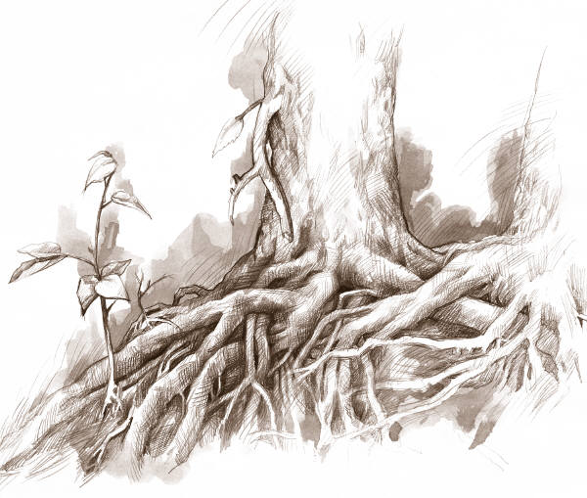
the tree provides carbohydrates as food source.

