Name: _____________________________ Hour: ____________

_ _ _ _ _ _ It is the Sarcodine that that you avoid in water be cause it causes dysentery

_ _ _ _ _ _ This substance give golden algae their clear shells

_ _ _ _ _ _ Brown algae are a rich source for this vital mineral

_ _ _ _ This algae is also known as sea lettuce

_ _ _ _ _ _ Only this gender of mosquito carries malaria

_ _ _ _ _ _ A ____________troph most consume its own food

_ _ _ _ _ This colored algae includes sea weed

_ _ _ _ _ _ This jelly-like substance holds algal cells together

_ _ _ _ _ _ _ (2 words) This event is a sign that shellfish have been poisoned

_ _ _ _ _ These tiny little hairs help the paramecium to move

_ _ _ _ _ This is the name for central support structure of kelp

_ _ _ _ _ _ _ _ _ Calcium Carbonate is also known as this

_ _ _ _ This product is harvested from Irish Moss

_ _ _ _ _ This colored algae are common in our lakes and ponds

_ _ _ _ _ _ _ _ _ _ _ This special vacuole help that paramecium to get rid of excess water

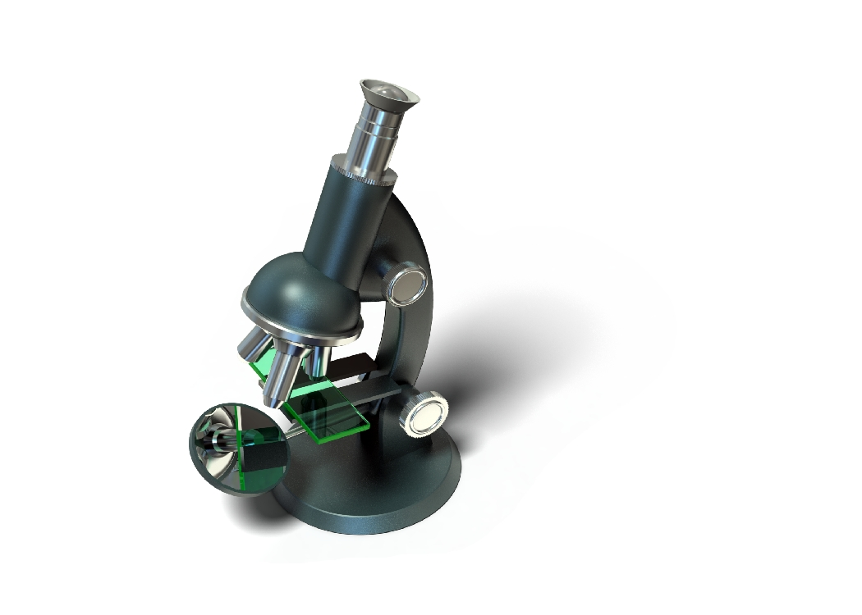

_ _ _ _ _ _ _ This is the only protists that is like a plant and animal

_ _ _ _ _ _ _ _ _ _ This sporozoan causes malaria

_ _ _ _ _ This substance is harvested from kelp

_ _ _ _ _ _ This colored algae gets its name from Carotene & Xanthophyll pigments

_ _ _ _ _ _ _ _ A euglena moves with this structure

_ _ _ _ _ _ _ This disease is carried by the Anopheles mosquito

_ _ _ _ _ _ _ _ _ _ _ Protists can share genetic material by doing this

_ _ _ _ _ _ _ _ _ _ _ _ _ _ This protist is responsible for the “Red Tide”

_ _ _ _ A(n) __________ troph can make its own food

_ _ _ This colored algae is delicate and only grows in deep water

_ _ _ _ _ _ _ _ _ This disease causes diarrhea and severe intestinal cramps

_ _ _ _ _ _ _ _ _ This algae is also known as the ‘horse hair worm’

_ _ _ _ _ _ _ _ (2 Words) This structure anchors kelp to the ocean floor

_ _ _ _ _ _ This protists has glass-like shells that resemble snowflakes

_ _ _ _ This is a common brown algae sometime referred to as sea weed

_ _ _ _ _ _ _ The body of an algae is known as this

_ _ _ _ _ _ This green algae resembles a ball of cells

_ _ _ _ _ _ _ _ _ _ _ _ Spreading this ‘earth’ made from golden algae kills bugs & slugs
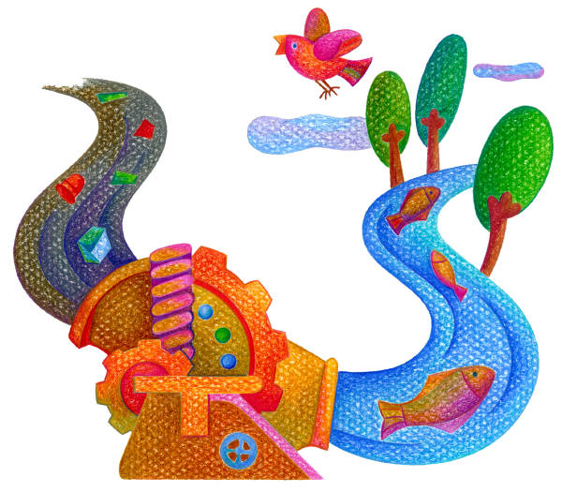
_ _ _ _ _ _ _ _ _ This is the scientific name for a ‘false foot’

