Love-A Socratic Seminar
Directions: On a separate document, offer ten annotations using the following boxes. You may compare, contrast, describe, evaluate, infer, trace, analyze, support, contradict, or explain the evidence you choose. Additionally, you may insert outside sources to support your conversation.
1  love noun, verb, loved, lov·ing.  (from dictionary.com)  1.  a profoundly tender, passionate affection for another person.  2.  a feeling of warm personal attachment or deep affection, as for a parent, child, or friend.  3.  sexual passion or desire.  4.  a person toward whom love is felt; beloved person; sweetheart.  5.  (used in direct address as a term of endearment, affection, or the like): Would you like to see a movie, love? | 2.(from dictionary.com)  Synonyms  1. tenderness, fondness, predilection, warmth, passion, adoration. 1, 2. Love, affection, devotion all mean a deep and enduring emotional regard, usually for another person. Love may apply to various kinds of regard: the charity of the Creator, reverent adoration toward God or toward a person, the relation of parent and child, the regard of friends for each other, romantic feelings for another person, etc. Affection is a fondness for others that is enduring and tender, but calm. Devotion is an intense love and steadfast, enduring loyalty to a person; it may also imply consecration to a cause. 2. liking, inclination, regard, friendliness. 15. like. 16. adore, adulate, worship.  Antonyms  1, 2. hatred, dislike. 15, 16. detest, hate.
3. SONNET 18  Shall I compare thee to a summer's day?  Thou art more lovely and more temperate:  Rough winds do shake the darling buds of May,  And summer's lease hath all too short a date:  Sometime too hot the eye of heaven shines,  And often is his gold complexion dimm'd;  And every fair from fair sometime declines,  By chance or nature's changing course untrimm'd;  But thy eternal summer shall not fade  Nor lose possession of that fair thou owest;  Nor shall Death brag thou wander'st in his shade,  When in eternal lines to time thou growest:  So long as men can breathe or eyes can see,  So long lives this and this gives life to thee. | 
5. “As Long as You Love Me” – Justin Bieber  As long as you love me  We could be starving, we could be homeless, we could be broke  As long as you love me  I'll be your platinum, I'll be your silver, I'll be your gold  As long as you love, love, love, love me (love me)  As long as you love, love, love, love me (love me) | “  6. ”You know you're in love when you can't fall asleep because reality is finally better than your dreams.”  –Dr. Seuss  -
 | 8. “You must know... surely, you must know it was all for you. You are too generous to trifle with me. I believe you spoke with my aunt last night, and it has taught me to hope as I'd scarcely allowed myself before. If your feelings are still what they were last April, tell me so at once. My affections and wishes have not changed, but one word from you will silence me forever. If, however, your feelings have changed, I will have to tell you: you have bewitched me, body and soul, and I love, I love, I love you. I never wish to be parted from you from this day on.” –Mr. Darcy expressing his devout love for Elizabeth Bennet  from Jane Austen’s Pride and Prejudice
9. “ Love Is” by Adrian Henri  Love is…  Love is feeling cold in the back of vans  Love is a fan club with only two fans  Love is walking holding paint stained hands  Love is.  Love is fish and chips on winter nights  Love is blankets full of strange delights  Love is when you don’t put out the light  Love is  Love is the presents in Christmas shops  Love is when you’re feeling Top of the Pops  Love is what happens when the music stops  Love is  Love is pink nightdresses still slightly warm  Love is when you have to leave at dawn  Love is  Love is you and love is me  Love is prison and love is free  Love’s what’s there when you are away from me  Love is… | 10.  “There is never a time or place for true love. It happens accidentally, in a heartbeat, in a single flashing, throbbing moment.”  –Sarah Dessen, The Truth About Forever
11. Forever and Always - Parachute  I want you forever, forever and always  Through the good and the bad and the ugly  We'll grow old together, and always remember  Whether happy or sad or whatever  We'll still love each other, forever and always  Forever and always, forever and always | 11. B
12. “We come to love not by finding a perfect person, but by learning to see an imperfect person perfectly.”  –Sam Keen, from “To Love and Be Loved” | 13. “It would degrade me to marry Heathcliff now; so he shall never know how I love him: and that, not because he's handsome, Nelly, but because he's more myself than I am. Whatever our souls are made of, his and mine are the same; and Linton's is as different as a moonbeam from lightning, or frost from fire…My love for Linton is like the foliage in the woods: time will change it, I'm well aware, as winter changes the trees. My love for Heathcliff resembles the eternal rocks beneath: a source of little visible delight, but necessary. Nelly, I am Heathcliff! He's always, always in my mind: not as a pleasure, any more than I am always a pleasure to myself, but as my own being. So don't talk of our separation again: it is impracticable.” –Catherine Earnshaw from Emily Bronte’s Wuthering Heights
 | 15. “Love is patient and kind; love does not envy or boast; it is not arrogant or rude. It does not insist on its own way; it is not irritable or resentful; it does not rejoice at wrongdoing, but rejoices with the truth. Love bears all things, believes all things, hopes all things, endures all things. Love never ends. As for prophecies, they will pass away; as for tongues, they will cease; as for knowledge, it will pass away.”  1 Corinthians 13:4-8 –Bible
16. Jean Gabor, “The Child In Him”  I loved the child in him  so innocent and sweet  The mischief in his eyes  the blush upon his cheek  The tender way he spoke  that showed me that he cared  The touch of his warm hand  that gently touched my hair  The smiles that we shared  that filled my life with glee  For when I was with him  I found the child in me | 17. “I finally understood what true love meant...love meant that you care for another person's happiness more than your own, no matter how painful the choices you face might be.”  ― Nicholas Sparks, Dear John
18. “If I should stay,  I would only be in your way  So I'll go,  But I know  I'll think of you every step of the way  And I...  Will always  Love you, oohh  Will always  Love you  You  My darling you…”  “I Will Always Love You” –Whitney Houston | 
20. “I have found the paradox, that if you love until it hurts, there can be no more hurt, only more love.”  - Mother Teresa | 21. “You Give Love a Bad Name”- Bon Jovi  “Shot through the heart and you're to blame  You give love a bad name  (Bad name)  I play my part and you play your game  You give love a bad name  (Bad name)  Hey, you give love a bad name”
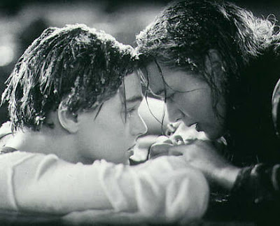 | 23.“Friends can help each other. A true friend is someone who lets you have total freedom to be yourself - and especially to feel. Or, not feel. Whatever you happen to be feeling at the moment is fine with them. That's what real love amounts to - letting a person be what he really is.” –Jim Morrison
24. Divorce Rate | 25. Biological models tend to view love as a mammalian drive, much like hunger or thirst. Helen Fisher, a leading expert in the topic of love, divides the experience of love into three partly overlapping stages: lust, attraction, and attachment.  Lust is the feeling of sexual desire;  Romantic attraction determines what partners’ mates find attractive and pursue, conserving time and energy by choosing;  Attachment involves sharing a home, parental duties, mutual defense, and in humans involves feelings of safety and security.  Three distinct neural circuitries, including neurotransmitters, and also three behavioral patterns, are associated with these three romantic styles.
  Rank | Countries | Amount
  # 1 | United States: | 4.95 per 1,000 people
  Top of Form
  Bottom of Form
  # 2 | Puerto Rico: | 4.47 per 1,000 people
  Top of Form
  Bottom of Form
  # 3 | Russia: | 3.36 per 1,000 people
  # 4 | United Kingdom: | 3.08 per 1,000 people
  Bottom of Form
  # 5 | Denmark: | 2.81 per 1,000 people
  # 6 | New Zealand: | 2.63 per 1,000 people
  Top of Form
  Bottom of Form
  # 7 | Australia: | 2.52 per 1,000 people
  Top of Form
  Bottom of Form
  # 8 | Canada: | 2.46 per 1,000 people
  # 9 | Finland: | 1.85 per 1,000 people
  Top of Form
  Bottom of Form
  # 10 | Barbados: | 1.21 per 1,000 people
  Top of Form
  Bottom of Form
26. 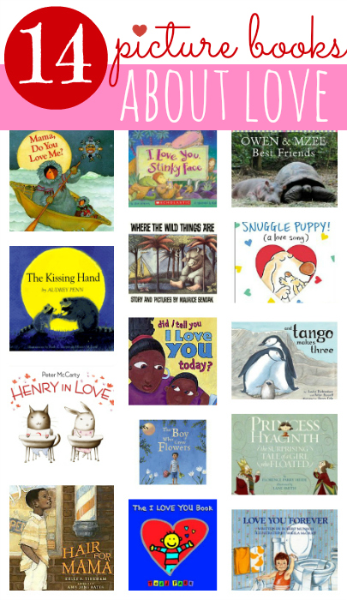 | 27. Top Ten Minus Two Best Love Songs  - -I Will Always Love You - Whitney Houston  - -My Heart Will Go On - Celine Dion  - -God Only Knows - The Beach Boys  - -My Immortal - Evanescence  - -I Don't Want to Miss a Thing - Aerosmith  - -Everything I Do (I Do It for You) -Bryan Adams  - -You're Still the One - Shania Twain  - -Manhattan Skyline - A-Ha
28. In contemporary Chinese, Ai (愛) is often used as the equivalent of the Western concept of love. Ai is used as both a verb (e.g. wo ai ni 我愛你, or "I love you") and a noun (such as aiqing 愛情, or "romantic love"). However, due to the influence of Confucian Ren, the phrase ‘Wo ai ni’ (I love you) carries with it a very specific sense of responsibility, commitment and loyalty. Instead of frequently saying "I love you" as in some Western societies, the Chinese are more likely to express feelings of affection in a more casual way. Consequently, "I like you" (Wo xihuan ni, 我喜欢你) is a more common way of expressing affection in Chinese; it is more playful and less serious. This is also true in Japanese (suki da, 好きだ). The Chinese are also more likely to say "I love you" in English or other foreign languages than they would in their mother tongue. | 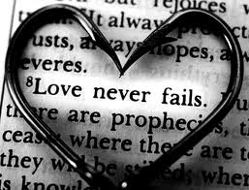
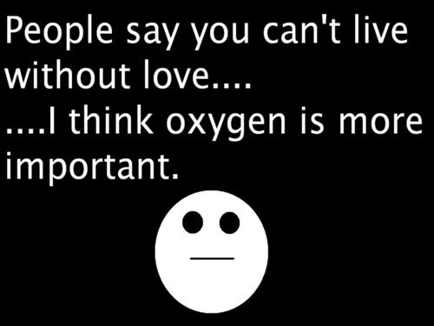  30. | 31. Maslow’s Hierarchy of Needs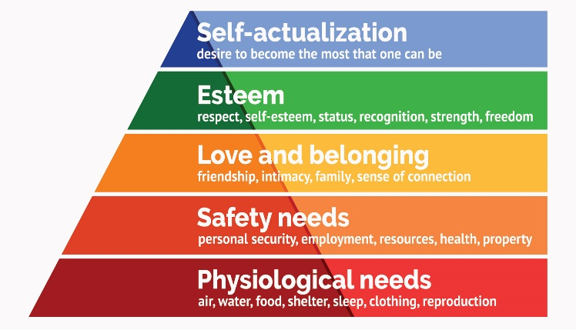
32. “Goodbye Note” Sadie Raines (2008)  I never thought this day would come.  I truly thought you were the one.  We use to laugh and talk all night.  Now we argue, fuss, and fight.  All is wrong in things I do.  To take the blame is never you.  So quick to run when things get rough.  Your best excuse is just too tough.  Home alone has become my life.  Did you forget you had a wife?  I keep it secret when things turn bad.  Because our kids love their dad.  I'll sleep tonight on what I wrote.  As I leave this good-bye note. | 33. The numbers. According to marriage statistics, the numbers have proven to look very promising for the idea of marriage. In 2005, the divorce rate was at 3.6 per a thousand people. This was the same in 2008 in which both years had the lowest rate of divorce in the past 40 years. On the other hand, in the same span of time, the number of people that got married was a bit lower. This could also be the reason why fewer people got divorced as well. However, more and more couples this day and age opt to live together first before choosing to get married. So this could also be another factor why the divorce rate is down.  Age of settling down. On average, a lot of couples that get married have ages that are also higher over the last ten years. For men, the age of settling down is 27. With women, the age is 26. Both ages are higher by a number of one over the last ten years.  Do know that the numbers in marriage statistics only serves as a guide. These figures do not necessarily entail what your marriage is going to be like as you have to factor in the human experience as well. It really depends on how a couple feels about each other in the end.
34.  | 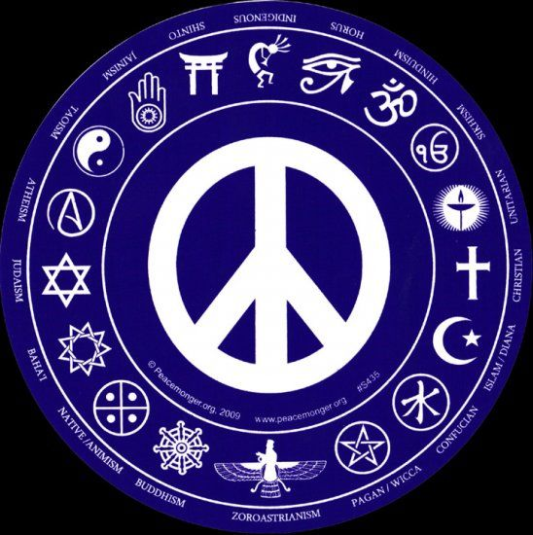
36. 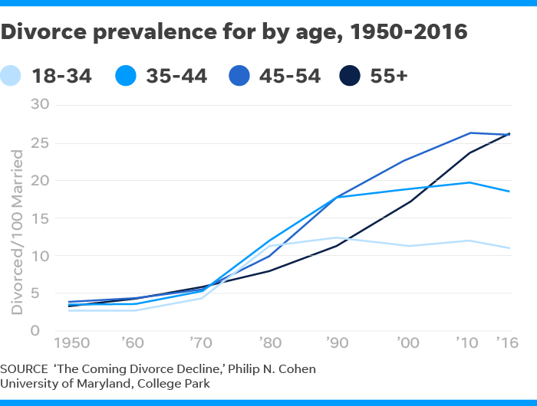 | 37. 
38. 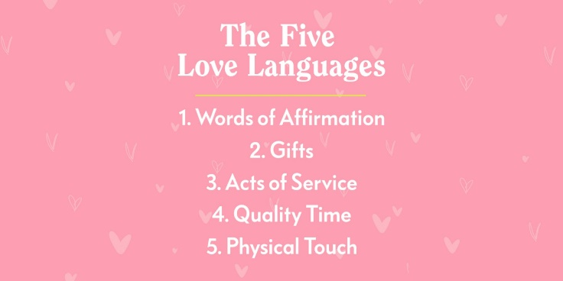 | 39. “A flower cannot blossom without sunshine, and man cannot live without love.”  -Max Muller
40. “Immature love says, 'I love you because I need you.'  Mature love says, 'I need you because I love you.'”  -Erich Fromm | 41. Daily Love and Romance Horoscope looks at your love potential and compatibility for the coming days.
  Aries  Mar 21 - Apr 19 | Taurus  Apr 20 - May 20 | Gemini  May 21 - Jun 20
  Cancer  Jun 21 - Jul 22 | Leo  Jul 23 - Aug 22 | Virgo  Aug 23 - Sep 22
  Libra  Sep 23 - Oct 22 | Scorpio  Oct 23 - Nov 22 | Sagittarius  Nov 22 - Dec 21
  Capricorn  Dec 22 - Jan 19 | Aquarius  Jan 20 - Feb 18 | Pisces  Feb 19 - Mar 20
42. The Lovers by Rene Magritte (1928)  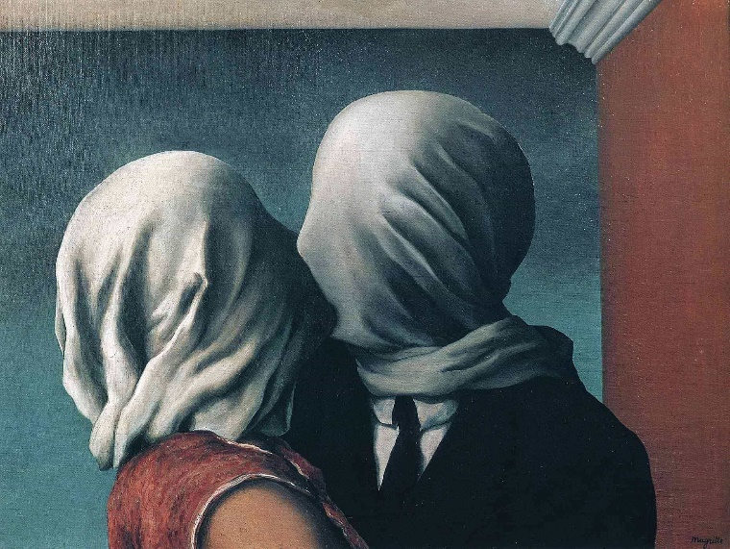 | 43. Christopher Robin and Winnie the Pooh  (Thanks to Brooke B.)
44. The Science of Neglect (Childhood development research from Harvard University) | 45. Traditional Wedding Vows from Various Religions

